THE INFORMATION IN THIS BOX IS NOT A PART OF THE CONTRACT AND IS FOR COUNTY USE ONLY
Contract Number
12-408 A4
SAP Number


Real Estate Services Department

Department Contract Representative | Terry W. Thompson, Director
Telephone Number | (909) 387-5000

Contractor | The Phoenix, LLC
Contractor Representative | James V. Dickey
Telephone Number | 909-237-2777
Contract Term | September 5, 2013 – January 31, 2035
Original Contract Amount | $5,659,032.00
Amendment Amount | $8,885,405.31
Total Contract Amount | $14,544,437.31
Cost Center | 7810001000
GRC/PROJ/JOB No. | 5700 2954
Grant Number (if applicable)

IT IS HEREBY AGREED AS FOLLOWS:

WHEREAS, San Bernardino County (“COUNTY”), as tenant, and The Phoenix, LLC (“LANDLORD”), as landlord, have entered into Lease Agreement, Contract No. 12-408 dated June 19, 2022 , as amended by the First Amendment dated April 8, 2014, the Second Amendment dated February 10, 2015, and the Third Amendment dated November 1, 2016 (collectively, the "Lease"), wherein LANDLORD leases certain premises to the COUNTY, which Lease expired on September 4, 2023; and has since been on a permitted month-to-month holdover; and,

WHEREAS, the COUNTY and LANDLORD now desire to amend the Lease to extend the term for a total of ten (10) years from February 1, 2025 through January 31, 2035 through the County’s concurrent exercise of the two existing five (5) year extension options; and

WHEREAS, the COUNTY and LANDLORD now desire to amend the Lease to reflect additional tenant improvements on the terms and conditions set forth herein, and amend certain other terms of the Lease as set forth in this amendment (the “Fourth Amendment”).

NOW, THEREFORE, in consideration of mutual covenants and conditions and the foregoing recitals which are hereby incorporated by reference, the parties hereto agree the Lease is amended as follows:

- Pursuant to Lease Paragraph 8, HOLDING OVER, COUNTY shall, with LANDLORD’s express consent granted herein, use the Premises on a month-to-month holdover term for the period of September 5, 2023 through January 31, 2025, in the total amount of $852,960.27 calculated as $46,590.27 of prorated rent for September 2023 and $53,758 per month for October 1, 2023-January 31, 2025 .

- Effective February 1, 2025, pursuant to the COUNTY’s concurrent exercise of two existing five-year extension options in Paragraph 6, OPTION TO EXTEND TERM, DELETE in its entirety the existing Paragraph 3., TERM and SUBSTITUTE therefore the following as a new Paragraph 3., TERM:

- TERM:

The term of the Lease is extended for ten (10) years for the period of February 1, 2025 through January 1, 2035 (the “First Extended Term”).

- Effective February 1, 2025, DELETE the existing Paragraph 4.A, RENT and SUBSTITUTE therefore the following as a new Paragraph 4.A, RENT:

A. COUNTY shall pay to Landlord the following monthly rental payments in advance on the first day of each month, commencing when the term commences, continuing during the term:

Lease Year | Monthly Rent |  | Monthly Amortization of Improvements |  | Total Monthly Payment
February 1, 2025 - January 31, 2026 | $55,162.25 | + | $0 | = | $55,162.25
February 1, 2026 - January 31, 2027 | $56,817.12 | + | $0 | = | $56,817.12
February 1, 2027 - January 31, 2028 | $58,521.63 | + | $4624.63 | = | $63,146.26
February 1, 2028 - January 31, 2029 | $60,277.28 | + | $4624.63 | = | $64,901.91
February 1, 2029 - January 31, 2030 | $62,085.60 | + | $4624.63 | = | $66,710.23
February 1, 2030 - January 31, 2031 | $63,948.17 | + | $4624.63 | = | $68,572.80
February 1, 2031 - January 31, 2032 | $65,866.61 | + | $4624.63 | = | $70,491.24
February 1, 2032 - January 31, 2033 | $67,842.61 | + | $4624.63 | = | $72,467.24
February 1, 2033 - January 31, 2034 | $69,877.89 | + | $4624.63 | = | $74,502.52
February 1, 2034 - January 31, 2035 | $71,974.22 | + | $4624.63 | = | $76,598.85

- Effective February 1, 2025, DELETE the existing Paragraph 6, OPTION TO EXTEND TERM and SUBSTITUTE therefore the following as a new Paragraph 6, OPTION TO EXTEND TERM:

    - LANDLORD gives COUNTY the option to extend the term of the Lease on the same provisions and conditions, except for the monthly rent, for two (2) five-year periods ("extended terms") following expiration of the First Extended Term, by COUNTY giving notice of its intention to exercise the option to LANDLORD prior to the expiration of the preceding term or during any holding over pursuant to Paragraph 8, HOLDING OVER. The rent for each extended term shall be adjusted by good faith negotiation of the parties to the fair market rental rate then prevailing based upon the rental rates of comparable leased property in San Bernardino County.

If the parties have been unable to agree upon the said fair market rental rate within five (5) months of the COUNTY's notice to exercise an option for an extended term, said fair market rental rate shall be determined through arbitration conducted in accordance with the Commercial Arbitration Rules of the American Arbitration Association

      - The negotiations and any dispute resolution method used will be guided by the fact that the monthly rent in Paragraph 4, RENT, includes amounts for basic rent for space and payment for building Improvements made by LANDLORD under Paragraph 41, LANDLORD'S IMPROVEMENTS. The basic rent for space starts at Two Dollars and Seventy-Five cents ($2.75) per square foot and increases at the rate of three percent (3%) per year to end at the rate of Three Dollars and Fifty-Nine Cents ($3.59) per square foot. All LANDLORD Improvements will have been paid for within the First Extended Term and no further payment for these Improvements will be made by COUNTY. The negotiated/arbitrated rent shall be based upon the basic rental rate for space and shall not include any rental amount for the Landlord's Improvements.

- Effective February 1, 2025, DELETE in its entirety the existing Paragraph 40, COUNTY'S RIGHT TO TERMINATE LEASE and SUBSTITUTE therefore the following as a new Paragraph 40, COUNTY'S RIGHT TO TERMINATE LEASE:

40. COUNTY’S RIGHT TO TERMINATE LEASE: The COUNTY shall have the right to terminate this Lease at any time on or after February 1, 2033, whenever COUNTY, in its sole discretion, determines it would be in COUNTY's best interests to terminate this Lease. The Director of Real Estate Services Department shall give notice of any termination pursuant to this paragraph at least on hundred eighty (180) days prior to the date of termination.

- Effective January 14, 2025, DELETE the existing Paragraph 41 Subsections A., B., C., E., F., G., H., and I., LANDLORD’S IMPROVEMENTS, and SUBSTITUTE therefore the following as a new Paragraph 41 Subsections A., B., C., E., F., G., H., and I., LANDLORD’S IMPROVEMENTS, and ADD Exhibit “G” – ADDITIONAL TENANT IMPROVEMENTS referred to herein and incorporated into the Lease. New Paragraph 41, to read as follows:

41. LANDLORD’S IMPROVEMENTS:

A. LANDLORD, at its sole cost and expense but subject to the COUNTY’s reimbursement as set forth in Paragraph 41.C, and as applicable, Paragraph 41.D of this Fourth Amendment, agrees to make the improvements to the Premises as more specifically set forth in Exhibit "G ", Additional Tenant Improvements and the Lease, including but not limited to this Paragraph 41, LANDLORD’S IMPROVEMENTS and Paragraph 11, HEALTH, SAFETY, AND FIRE CODE REQUIREMENTS (collectively, the "2024 Improvements"). The 2024 Improvements shall be deemed completed on the date that LANDLORD has completed the 2024 Improvements in substantial accordance with Exhibit “G” and the Lease, including but not limited to this Paragraph 41, LANDLORD’S IMPROVEMENTS and Paragraph 11, HEALTH, SAFETY, AND FIRE CODE REQUIREMENTS, (“Required Condition”), subject to minor punch list items agreed by the parties, which, subject to force majeure, shall be completed by LANDLORD within ten (10) business days after punchlist has been provided to LANDLORD from COUNTY.

- The parties agree that, as of the Fourth Amendment Effective Date, LANDLORD’s total cost, including the cost of the construction drawings for the 2024 Improvements is estimated to be $304,770.00 (“Total Improvement Cost”) and the COUNTY shall reimburse LANDLORD for a portion of said total cost in the amount of $304,770.00 (“County Reimbursement Amount”), which cost shall be amortized, plus interest at the rate of ten per cent (10%) per annum monthly over the First Extended Term at $4,624.63 per month and payable by COUNTY, commencing on November 1, 2026, as set forth in Paragraph 4.A, RENT (“Monthly Amortized 2024 Improvement Payment”).

- Notwithstanding anything to the contrary in Paragraph 41.C above, the parties hereby acknowledge that the Total Improvement Cost is subject to change should the COUNTY make any changes to the 2024 Improvement plan and specifications after the Fourth Amendment Effective Date. The County Reimbursement Amount shall be adjusted to the actual cost reasonably incurred by LANDLORD to install the 2024 Improvements (“Adjusted Improvement Cost”). In the event the Adjusted Improvement Cost is less than the Total Improvement Cost, the parties shall execute an amendment to the Lease to proportionately reduce the County Reimbursement Amount and the Monthly Amortized 2024 Improvement Payment. In the event the Adjusted Improvement Cost exceeds the Total Improvement Cost, such difference shall be known as an “Overage” and LANDLORD shall provide COUNTY with written notice of such Overage (“Overage Notice”) within thirty (30) days after LANDLORD’s receipt of the Final Bid.

- In the event that the Overage is $100,000 or less (“Level 1 Overage”), the parties shall have thirty (30) days after the COUNTY’s receipt of the LANDLORD’s Overage Notice to negotiate modifications to the 2024 Improvements in good faith to reduce or eliminate the Level 1 Overage. Any resulting Level 1 Overage as agreed by the parties shall be documented as a Change Order and shall be paid by purchase order(s) in accordance with Paragraph 41.G.

- In the event that the Overage is more than $100,000 (“Level 2 Overage”), the following process shall apply:

- Within thirty (30) days after COUNTY’s receipt of an Overage Notice from LANDLORD, the COUNTY shall provide LANDLORD with written notice (“Level 2 Overage Election Notice”) to elect, at its sole discretion, one of the following options:

- Negotiate modifications to the 2024 Improvements to reduce or eliminate the Level 2 Overage; in which case, the parties shall have thirty (30) days after LANDLORD’s receipt of the COUNTY’s Level 2 Overage Election Notice to negotiate in good faith and mutually agree on any such modifications (with the parties to promptly confirm in writing the end date of said thirty (30) day period following LANDLORD’s receipt of the COUNTY’s Level 2 Overage Election Notice) and the COUNTY shall pay such agreed overage in accordance with Paragraph 41.D(ii)(b), provided that if modifications are not mutually agreed on or before the confirmed end date of said thirty (30) day period, the COUNTY shall be deemed to have exercised its option in Paragraph 41.D.(ii)(a)(3), rendering this Fourth Amendment null and void and without legal effect; or

- Agree to pay the entire Level 2 Overage in accordance with Paragraph 41.D(ii)(b); or

- Rescind the extension of the term of this Lease for ten years, as provided in Paragraph 3 of this Fourth Amendment (without any requirement to use the COUNTY’s contingency for the Excess Cost Cap in Paragraph 41.G); in which case the entirety of this Fourth Amendment shall be deemed null and void and without any legal effect and the Lease shall expire on its current expiration date of.

- The COUNTY shall, at its sole discretion, pay for any Level 2 Overage resulting from its election of either Paragraph 41.D(ii)(a)(1) or (2) by: (I) purchase order(s) in accordance with Paragraph 41.G, provided that any such Level 2 Overage that exceeds the Excess Cost Cap (as defined in Paragraph 41.G) is subject to further approval from the COUNTY’s Board of Supervisors; and/or (II) in an amount to be amortized monthly over the First Extended Term, which amount would be in addition to the Monthly Amortized 2024 Improvement Payment set forth in Paragraph 4.A for the First Extended Term, provided that any such additional amortized amount is subject to further approval from the COUNTY’s Board of Supervisors. If further approval from the COUNTY’s Board of Supervisors is required, the COUNTY shall have ninety (90) days from the COUNTY’s Level 2 Overage Election Notice to obtain such approval. If such approval is not timely obtained, then this Fourth Amendment shall be deemed null and void and without legal effect.

- Notwithstanding anything to the contrary in this Paragraph 41.D(ii), in the event that this Fourth Amendment would be deemed null and void in accordance with the process in Paragraph 41.D(ii) (including any sub-paragraphs), LANDLORD has the right to supersede such nullification and continue the Lease in accordance with this Fourth Amendment by paying the entire amount of the Level 2 Overage that exceeds $100,000.00 at its sole cost and expense and without any reimbursement by the COUNTY by providing the COUNTY with written notice of election such later than thirty (30) days after the Fourth Amendment would be deemed null and void; in which case the COUNTY shall pay the first $100,000.00 of the Level 2 Overage.

D. Subject to force majeure (as defined below) and any delays caused by Tenant, LANDLORD shall diligently pursue the 2024 Improvements to completion in the Required Condition by no later than October 31, 2026, (“Completion Date”). LANDLORD agrees to provide the COUNTY a written progress report every sixty (60) days after the mutual execution of this Fourth Amendment. The report shall contain up-to-date information of reasonably pertinent to construction progress, including but not limited to notification of any permit approval. The LANDLORD shall thereafter diligently pursue the 2024 Improvements to completion in the Required Condition by the Completion Date. LANDLORD shall immediately (but not less than three days after occurrence) notify COUNTY in writing of any anticipated or actual delays to the Completion Date, including those LANDLORD alleges are caused by the COUNTY. In the event LANDLORD fails to timely notify COUNTY in writing of any such delay and/or if such delays are not verified by COUNTY acting reasonably as being caused by COUNTY or force majeure, the Completion Date shall not be modified and COUNTY shall have the remedies set forth in Paragraph 41,F. If LANDLORD provides written notice of such delay and COUNTY verifies that such delay is caused by COUNTY or force majeure, the Completion Date shall be extended for a period equivalent to the period of such verified delay. As used in this Fourth Amendment, the term “force majeure” shall mean that to the extent that a party’s performance of any of its obligations (expressly excluding Tenant’s monetary obligations set forth in Paragraph 4.A of this Fourth Amendment any subsequent amendment to said paragraph) in relation to the 2024 Improvements is prevented or delayed directly due to fire, flood, earthquake, acts of God, pandemic, public health emergency, acts of war, riots, governmental delays, supply chain delays, or an any similar cause beyond the reasonable control of such party and such non-performance could not have been prevented by reasonable precautions, then the non-performing party shall be excused from such the non-performance for only so long as the force majeure event continues.

E. LANDLORD acknowledges that late delivery of the 2024 Improvements to COUNTY in the Required Condition after the Completion Date (subject to extension as set forth in Section (D)) above will cause COUNTY to incur costs not contemplated by the Lease and this Fourth Amendment, the exact amount of such costs being extremely difficult and impracticable to fix. Therefore, if LANDLORD does not deliver the 2024 Improvements in the Required Condition by the Completion Date (as maybe extended) and said delay is not caused by the County or force majeure. LANDLORD agrees to pay the COUNTY liquidated damages of Five Hundred and 00/00 Dollars ($500.00) for each day of delay, commencing from Completion Date (as may be extended) until such time as the 2024 Improvements are delivered in the Required Condition, excluding minor punch list items. The parties agree that this charge represents a fair and reasonable estimate of the costs that COUNTY will incur by reason of late delivery. Acceptance of any charge shall not constitute a waiver of LANDLORD's default or prevent COUNTY from exercising any of the other rights and remedies available to COUNTY.

F. In the event that during construction of the 2024 Improvements, there is an Overage pursuant to paragraph 41.D or an authorized representative of the COUNTY requests any other new specifications or any modifications to then existing specifications for the 2024 Improvements, the Overage or other proposed new specifications or modifications will be classified as a proposed change order, and prior to incurring any costs or commencing any work for any Overage or other proposed change order, the parties shall following the approval process in Paragraph 41.D for an Overage and the LANDLORD must promptly provide the COUNTY’s authorized representative with the cost and timing impacts for any other proposed change order. If the COUNTY approves the Overage in accordance with Paragraph 41.D or approves the cost and timing impacts for any other proposed change order, the authorized representatives of the parties will execute a written change order documenting the agreed Overage or other new or modified specifications, costs, and timing for the subject work (“Approved County Change Order”). LANDLORD will thereafter contract directly with its contractors and/or vendors to commence and complete the Approved County Change Order. COUNTY’S authorized representative may process change orders for any approved Overage or for one or more other proposed change orders in accordance with this paragraph, provided that the total of all Approved County Change Orders (whether for an approved Overage or for any other approved change orders) shall not exceed an aggregate amount of One Hundred Thousand Dollars ($100,000) (“Excess Cost Cap”), which shall be paid by the COUNTY TO LANDLORD through a COUNTY purchase order upon completion of the change order work and without an adjustment to the Amortized 2024 Improvement Payment during the First Extended Term as set forth in Paragraph 4.A, RENT except as set forth in Paragraph 41.D(ii)(b)(II). Any Approved County Change Order that causes the aggregate cost of all such approved change orders (whether for an approved Overage or for any other approved change orders) to exceed One Hundred Thousand Dollars ($100,000) shall require a formal amendment to this Lease that is executed by the authorized signatories of the parties prior to commencing any Overage or other proposed change order. County shall be fully responsible for any added costs or delays related to the Approved County Change Orders but only to the extent set forth in writing in the Approved County Change Order.

G. LANDLORD understands and agrees that from the time that this Fourth Amendment is executed through the completion of the 2024 Improvements in the Required Condition, LANDLORD shall not assign or transfer a controlling interest in the Premises to a third party, without COUNTY's prior review and approval, which approval shall not be unreasonably withheld, delayed or conditioned. COUNTY agrees that it will consent to any change among the members of LANDLORD after which James Dickey, Sara Sinatra, Amy Console or any combination of them or trusts created by or for the benefit of any of them remains the holder of the majority of the voting membership interests in LANDLORD. LANDLORD understands and agrees to provide to COUNTY all documents and relevant information concerning any proposed transfer. COUNTY will have ten (10) business days after receiving all such documents and information to complete its review. Upon COUNTY approval of an assignment or transfer, the parties shall immediately execute an amendment to this Lease stating the change of ownership of the Premises.

H. LANDLORD, at its sole expense, but subject to the COUNTY’s reimbursement as set forth in Paragraph 41.C, and as applicable, Paragraph 41.D of this Fourth Amendment, as part of the Total Improvement Fixed Costs, must furnish all of the design, material, labor and equipment required to construct the 2024 Improvements in the Required Condition, apply for and obtain all permits, licenses, certificates, and approvals necessary for the construction of the 2024 Improvements, and provide all site plans (including elevations of the building and details of the exterior finish), space design plans, construction plans and provide such plans to COUNTY on a compact disc-recordable (CD-R) in file format compatible with MS-DOS and AutoCAD 2002 software (.dwg file extension).

- Effective January 14, 2025, ADD Paragraph 57, CAMPAIGN CONTRIBUTION DISCLOSURE (SB 1439) and Exhibit “H” – CAMPAIGN CONTRIBUTION DISCLOSURE (SB 1439) incorporated and attached herein, which new Paragraph 57 shall read as follows:

57. CAMPAIGN CONTRIBUTION DISCLOSURE (SB 1439): LANDLORD has disclosed to the COUNTY using Exhibit “H” - Campaign Contribution Disclosure Senate Bill 1439, whether it has made any campaign contributions of more than $500 to any member of the Board of Supervisors or other County elected officer [Sheriff, Assessor-Recorder-Clerk, Auditor-Controller/Treasurer/Tax Collector and the District Attorney] within the earlier of: (1) the date of the submission of LANDLORD’s proposal to the COUNTY, or (2) 12 months before the date this Lease was approved by the Board of Supervisors. LANDLORD acknowledges that under Government Code section 84308, LANDLORD is prohibited from making campaign contributions of more than $500 to any member of the Board of Supervisors or other COUNTY elected officer for 12 months after the COUNTY’s consideration of the Lease.

In the event of a proposed amendment to this Lease, the LANDLORD will provide the COUNTY a written statement disclosing any campaign contribution(s) of more than $500 to any member of the Board of Supervisors or other COUNTY elected officer within the preceding 12 months of the date of the proposed amendment.

Campaign contributions include those made by any agent/person/entity on behalf of the LANDLORD or by a parent, subsidiary or otherwise related business entity of LANDLORD.

8. This Fourth Amendment may be executed in any number of counterparts, each of which so executed shall be deemed to be an original, and such counterparts shall together constitute one and the same Fourth Amendment. The parties shall be entitled to sign and transmit an electronic signature of this Fourth Amendment (whether by facsimile, PDF or other email transmission), which signature shall be binding on the party whose name is contained therein. Each party providing an electronic signature agrees to promptly execute and deliver to the other party an original signed Fourth Amendment upon request.

[THE REMAINDER OF THIS PAGE LEFT INTENTIONALLY BLANK]

9. All other provisions and terms of the Lease shall remain the same and are hereby incorporated by reference. In the event of any conflict between the Lease and this Fourth Amendment, the terms of this Fourth Amendment shall control.

END OF FOURTH AMENDMENT.

SAN BERNARDINO COUNTY |  |  |  | THE PHOENIX, LLC
 |  |  |  | By
, Chair, Board of Supervisors |  |  |  |  | (Authorized signature - sign in blue ink)
Dated: |  |  |  | Name |  |  | James V. Dickey
SIGNED AND CERTIFIED THAT A COPY OF THIS
DOCUMENT HAS BEEN DELIVERED TO THE
CHAIRMAN OF THE BOARD |  |  |  | Title |  | Manager
Lynna Monell
Clerk of the Board of Supervisors
San Bernardino County
By |  |  |  | Dated:
 | Deputy |  |  | Address |  |  |  |  | 249 W. Orange Show Lane
 |  |  |  |  |  |  |  |  | San Bernardino, CA 92408

FOR COUNTY USE ONLY
Approved as to Legal Form |  |  |  | Reviewed for Contract Compliance |  |  |  | Reviewed/Approved by Department
John Tubbs II, Deputy County Counsel |  |  |  |  |  |  |  | Lyle Ballard, Real Property Manager, RESD
Date |  |  |  | Date |  |  |  | Date

HUMAN SERVICES (COUNTY)
TRANSITIONAL ASSISTANCE DEPARTMENT
32353 Yucaipa Blvd., Yucaipa

GENERAL GUIDELINES:

This document is intended to be used as a reference for design professionals and a room-by-room list of improvements specific to the project to aid in estimating costs.

HUMAN SERVICES acknowledges that Exhibit “A” Premises Design Standards and Specifications sets forth the COUNTY’S design standards and that only certain portions of the COUNTY’S design standards will apply to the improvements to be constructed pursuant to the Room-by-Room list in Section 3.0.

Abbreviations:

AP1 - Acoustical panels
CACB - COUNTY approved color board
C1 - Carpet tiles
CT1 - Ceramic or porcelain floor tile (lobby)
CT2 - Glazed ceramic wall tile (restroom)
CT3 - Glazed ceramic wall tile (accent)
CT4 - Ceramic or porcelain floor tile (restroom/janitor)
P1 - Low Sheen/Eggshell
P2 - Low sheen/Eggshell (accent)
P3 - Low sheen/Eggshell (accent)
P4 - Semi-gloss
B1 - Ceramic tile wall base
B2 - Rubber wall base
VCT - Vinyl Composition tile flooring
LVT - Luxury vinyl tile (planks)
WF - Walk-off flooring

1.0 CONSTRUCTION GUIDELINES

1.1 CEILINGS:
- 2' x 4' suspended acoustic ceiling with exposed ceiling tile tee systems, white. Fire rated system in areas required by Code.
- Ceiling height to be nine feet (9'-0”), unless otherwise specified.
- Three-fourths inch (3/4”) thick Armstrong #1811 Fine Fissured High NRC acoustical ceiling panels, NRC range 0.70, color - white.

1.2 LIGHTING:
- 2' x 4' drop-in fixtures or as allowed by current Energy Codes. Lighting must meet all Building Codes applicable to commercial office buildings. All rooms to have separate lighting controls (switches or light sensors).
- Lighting fixtures must run parallel of work surfaces or shelving units in storage rooms. All reflected ceiling plans (light fixture locations) must be reviewed and coordinated with the modular furniture vendor and approved by the COUNTY.
- Provide additional emergency lighting for all restrooms and exit passages per local code approval. If lighting fixtures are utilized for emergency battery back-up lighting purposes, they must be marked by dots (no larger than 1/4”) or equivalent for easy identification. Dots must be able to be seen from floor level.
- All light switches that control lighting in lobbies or open work area are to be ganged together in the adjacent lobbies or open work areas. No light switches are to be located in areas used by the public.
- Lighting controls should be located convenient to the designated employee entrance.
- Locations of all light switches are to be approved by COUNTY.
- LANDLORD will be responsible for compliance with Title 24 including controlled electrical connection to COUNTY provided system furniture, per applicable energy code/s.

1.3 AIR CONDITIONING:
- The facility HVAC system shall be zone controlled properly to provide an even comfortable temperature throughout the facility as defined by the Mechanical Engineering Standards of ANSI/ASHRAE, unless noted otherwise. COUNTY is to approve HVAC control locations.
- Where existing construction is altered and/or the use of any portion of the building is changed; LANDLORD shall provide testing, adjusting and balancing of the HVAC system to maintain the standard in paragraph 1.3(a).
  - LANDLORD shall provide the COUNTY with a copy of the air and hydronic balance report from a “third party” firm duly licensed to inspect and certify the performance of the HVAC and other environmental systems.
- LANDLORD shall make any adjustments, repairs or replacement of equipment necessary to maintain the standard in paragraph 1.3(a).
- Air conditioning supply register: Shall be a two-way adjustable type if near a wall and four-way adjustable if in a room or open area. All registers are to be covered with tamper proof shields. Supply and return registers are to be approved by COUNTY.
- All rooms are to have ducted air conditioning supplies and returns. Except the Janitor, IDF and Telephone rooms.
- All main heating and air conditioning temperature controls shall be hard wired and placed in electrical room with hard wired remote sensors placed in the return air ducts or zone locations that are not accessible to tampering. All control locations are to be approved by COUNTY.
- Air conditioning requirements for the Telephone/Data Room are included in Exhibit “A” Section 2.0.

1.4 CEILING FANS:
- Ceiling fans are to be installed as noted on the floor plans and/or listed in the Room-by-Room Section 3.0.
- Fans are to be all white, 52”, 5 blades, three speeds, no lights and utilize in-wall controls. Acceptable manufacturer: Hunter Fan Company or COUNTY approved equal.
- Fan blades to be minimum of eight feet above finish floor unless otherwise approved by COUNTY.
- Fan controls shall be installed near lighting controls or convenient to the fan.

1.5 WINDOW COVERINGS:
- LANDLORD to provide window coverings at all windows unless otherwise noted or approved by COUNTY.
- Window coverings to be roller shade type providing solar insulation to reduce glare and heat gain. Type to be consistent throughout facility. Product, material and design to be approved by COUNTY. Acceptable manufacturer: Mecho, www.mechoshade.com, or COUNTY approved equal.

1.6 WALL CONSTRUCTION:

INTERIOR WALLS:
- The interior sides of all concrete or block walls are to be furred with a textured drywall finish, unless otherwise noted and approved by COUNTY.
- All interior walls shall be constructed to 4” above ceiling, at a minimum, unless otherwise noted and approved by COUNTY.
- All interior walls shall be finished with textured drywall, both sides, unless otherwise noted and approved by COUNTY.

INSULATION/SOUNDPROOFING:
- All wall cavities around hallways, restrooms, private offices, breakrooms; meeting/conference rooms, lobby areas and any special areas as specified by COUNTY shall be completely filled with insulation to help reduce sound transmission.
- If walls in these areas do not extend above T-bar, sound tape must be installed between finished ceiling and top wall track.

1.7 WALL FINISHES:

TILE:

- See “RESTROOM FACILITIES” section or as noted on the floor plans and/or listed in the Room-by-Room Section 3.0.

PAINT:
- All interior walls shall be orange peel textured with one coat of primer. Apply color topcoats needed to match the selected color chip provided by manufacturer, with a minimum of two coats of paint, the final coat rolled on for a smooth finish.
- Acceptable manufacturers: Dulux, Sinclair, or Dunn-Edwards.
- Paint colors (P1) Low sheen/Eggshell, (P2) Low sheen/Eggshell accent, (P3) Low sheen/Eggshell accent and (P4) Semi-gloss to be approved by COUNTY. Placement of accent P2, P3 and Semi-gloss P4 within the facility to be approved by COUNTY. All other painted walls will be P1.
- “Drawdowns” of selected paint colors to be provided prior to commencing work.

1.8 NOT USED:

1.9 NOT USED:

1.10 FLOORING:

CARPET:
- High-density carpet squares (C1). Manufacturer, type, color and placement in facility to be approved by COUNTY. The COUNTY is requesting when able to move toward a no VOC carpet installation whenever possible.
- Installation to be as per manufacturer recommendations, using only manufacturer’s approved adhesives and seam sealers as needed and as applicable to maintain manufacturer’s warranty.
- Rubber base to be installed in all carpeted areas. Manufacturer, type, color and placement in facility to be approved by COUNTY. Installation to be as per manufacturer recommendations.

VINYL FLOOR:
- Manufacturer, type, color and placement to be approved by COUNTY. COUNTY to designate vinyl floor selection and room location.
Armstrong Exelon vinyl tile (VT) 1/8” gauge, 12” x 12” with 4” rubber wall base. Manufacturer, type, color and placement to be approved by COUNTY.
- Vinyl planking manufacturer, type, color and placement to be approved by COUNTY.
- Welded seam manufacturer, type, color and placement to be approved by COUNTY.

PORCELAIN OR CERAMIC FLOOR TILE:
- Glazed floor tile (CT1) and (CT4) installed with a sanitary base to be of same manufacturer of tile selected. All flooring must meet ADA guidelines. Manufacturer, size, type, color, grout, and placement to be approved by COUNTY. (See: RESTROOM FACILITIES for additional tile requirements).

WALK-OFF FLOORING:
- When specified in Room by Room Section 3.0, entry/exit door areas in carpeted rooms to have commercial walk-off carpet tiles installed in a minimum five foot square area in front of the door or as shown on plan. Material to be coarse solution dyed fibers sufficient to scrape and remove dirt, debris and moisture from foot traffic and resistant to fading from exposure to sunlight. Install per manufacturer’s requirements using alternate adhesion method. Product, size and placement to be approved by COUNTY.
- When specified in Room by Room Section 3.0, entry/exit door areas in tiled rooms to have a shallow recessed commercial walk-off carpet tiles or entrance floor mat system installed in a minimum five foot square area in front of the door(s) or as shown on plan. Material to include coarse solution dyed fibers sufficient to scrape and remove dirt, debris and moisture from foot traffic and resistant to fading from exposure to sunlight. Install per manufacturer’s requirements using alternate adhesion method. Product, size and placement to be approved by COUNTY.

1.14 SIGNAGE:

INTERIOR:
- LANDLORD shall provide all Code required signs including, but not limited to, ADA, emergency evacuation and directional interior signage. COUNTY to approve wayfinding signage.
- Wayfinding signage to be coordinated with COUNTY and provided for: Public areas (i.e. Lobbies), and room names/numbers.

EXTERIOR:
- If exterior signage/monuments are present COUNTY has first right of refusal/approval to use as representing the COUNTY. LANDLORD will be responsible for design modifications, permits, fees and/or removal disposal costs.
- LANDLORD will provide exterior premises signage, as consistent with adjacent building/businesses, if applicable, and as approved by COUNTY.
- Raised, non-illuminated letters, monument type on stand-alone buildings, per City regulation and COUNTY approval.
- LANDLORD to provide building signage to have address and logo, COUNTY to approve logo design, (COUNTY to provide approved County branding/logo information packet).
- LANDLORD to provide entry door lettering: County name, agency name, and hours of operation and County “No Smoking” verbiage as allowed by jurisdiction and COUNTY approved.

1.15 CABINETRY:
- Unless otherwise noted, all exterior surfaces are to be of high-pressure laminate. All countertops to be of solid surface and/or high-pressure laminate with finished edges. If using high-pressure laminate materials the seams shall be placed and installed away from all water sources. Material and colors and shop drawings are to be approved by COUNTY prior to manufacturing.
- The inside of cabinets and drawers are to be completely lined with thermal fused material white in color.
- Unless otherwise noted, adjustable shelves in all cabinets, ¾” stock, thermal fused laminate material installed on all sides.
- Where water is present, countertop edges are to be elevated bull-nose or V-cap, with flat end trim. Counters in open areas must have rounded (radiused) corners.
- Heavy-duty hinges on all lower cabinets.
- ADA hardware on all cabinetry.
- 4” toe kick on all lower cabinets, unless prohibited by ADA requirements.

1.16 EMPLOYEE BREAKROOM/ CONFERENCE ROOM COFFEE BAR:
- Locking over-counter storage cabinets and locking under-counter storage cabinets and drawers with counter top per Section 1.15. Design and materials to be COUNTY approved.
- Counter top to be 34” finished height. Design and materials to be COUNTY approved.
- Soap and paper towel dispensers installed convenient to each sink and paper towel dispensers at each microwave, locations to be approved by COUNTY. Dispensers set at location and height to accommodate ADA requirements.
- Stainless steel double bowl sink, 36” wide, minimum of 7 ½” deep or at ADA requirements.
- ADA approved faucet set, deck mount, gooseneck spigot, stainless steel or chrome finish, washerless. Delta or COUNTY approved equal.
- Garbage disposal, minimum ½ h.p, In-Sink Erator or COUNTY approved equal.
- Water heater: Tankless, electric, under-counter. Set at 110 degrees, with a recirculating hot water loop to eliminate hot water wait times. Provide and install as needed to heat water at sinks and coffee station. COUNTY to approve selection.
- Space for 21 C.F. refrigerators with icemakers. See Room by Room Section 3.0 for quantities and project specific information. Plumbing connection for icemaker shall be recessed into wall, one per refrigerator.
- Space on counter top for 1 ½ C.F. microwave ovens. See Room by Room Section 3.0 for quantities and project specific information.
- All water line connections from recessed valves to refrigerators and/ or coffee stations must be made by LANDLORD and deemed operational.
- All break rooms shall be designed to minimize the migration of food/cooking smells into the general open work areas. Designs to include the segregation of the break areas into the more utility portions of the building and separately zoning the AC as to not carry odors into other areas, and placing high-volume, quiet exhaust fan/s inside the room at the door exiting into the work area, wiring the fan to the lighting for continual operation.
- Each appliance (i.e. microwave, coffee pot, toaster) shall have a dedicated circuit. See Room by Room Section 3.0 for quantities and project specific information.

1.17 DOORS AND DOOR HARDWARE:
- All door schedules and door hardware to be approved by COUNTY.
- All interior doors to be solid core. Acceptable manufacturer: Haley Bros. Color and finish to be approved by COUNTY.
- Schlage Heavy-Duty locksets are required and all lock functions are to be COUNTY approved, unless otherwise specified.
- Von Duprin 99 L-RH (LH for left side handle) 36” push bar panic device, 2060 finish shall be installed at all required panic bars locations. The Von Duprin electronic break away outer trim (L996E) shall be used with all panic devices prepared for the COUNTY card access system unless otherwise specified (see Figure 2). All other interior doors must have the Securitron UNL-24 electronic strike installed in the door frame where County card access is required. County will connect these card access components with a COUNTY approved vendor to a County owned card access system.
- Any interior or exterior door utilizing COUNTY installed card-access system must have installed at the door: data boxes - one in wall @ 42” from floor and one in ceiling above door for all proximity card readers; door closers; storeroom function locksets and fail-secure outer trim. See drawing for required conduit runs and data box installation locations (Figure 1).
- Push plates and pull handles instead of doorknobs or lever handles on rest room entrance doors, except for single occupant restrooms, or as described on the room-by-room specifications or as allowed by applicable code.
- Occupancy indicator hardware at single occupant restrooms.
- All lockable doors must be pinned using a Grand Master hierarchy. COUNTY to approve all sub masters and change keys. A copy of the pinning charts must be submitted to the COUNTY with the keys for the facility.
- All hardware must meet or exceed all applicable codes and ADA requirements.
- All exterior doors that lead into the lobby, hallways or any other work areas shall have a solid, waterproof overhead canopy extending at least 3 feet from the door with a width that covers the entire entrance area with overhead lighting below the canopy and above door.
- Door scope viewer: minimum 200 degree viewing angle. Install at all exterior employee entrance/exit doors. COUNTY to approve selection.
- LANDLORD shall provide an exterior wind-break with reinforced glass and mullions at the main entry into building to prevent wind gusts from entering main entry to the building. All designs will be discussed with LANDLORD during the plan development meetings. Design must meet ADA guidelines.
- Closers – to be installed at exterior doors and doors with card access system. Locations to be approved by COUNTY.

  - RESTROOM FACILITIES:

EMPLOYEE RESTROOMS:
- All tile, grout, surface materials, and colors to be COUNTY approved.
- Installation of all components, fixtures and signage must comply with all applicable health, safety, and ADA codes.
- Floors: Glazed porcelain tile, 2” x 2”, American Olean or Daltile (CT4). The sanitary base tile and trim to be of same tile selected.
- Walls: Glazed ceramic interior wall tile, 4 ¼” x 4 ¼”, American Olean or Daltile, (CT2), tiled floor to ceiling with an accent tile (CT3) or feature strip. A sanitary base to be of same manufacturer of tile selected. Use small grout width on all walls. Custom Building Products-Polyblend, or Hydromet Standard/Designer Series grout. Tile and grout colors to be selected by COUNTY.
- Ceilings: hard lid type. Semi-gloss paint color (P4). Apply per manufacturer’s requirements. Color to be selected by COUNTY.
- Lighting: Recessed canned lighting over sink and cabinet, minimum of one (1) light per sink.
- Rimless under-counter sinks with countertop to be 34” finished height or wall mounted sink at single occupancy restrooms. Mirrors to be installed above counters centered on sinks. Size and locations to be approved by COUNTY.
- Sink faucets to be Sloan, Optima Systems sensor operated electronic hand washing faucet #EAF-200-ISM with transformer, and grid strainer drain assembly #ETF-460-A.
- Water heater: Tankless, electric, under-counter. Set at 110 degrees, with a recirculating hot water loop to eliminate hot water wait times. Provide and install in each employee restroom. COUNTY to approve selection.
- Non-ADA toilets to be Kohler Wellcomme K4350, white, with Olsonite No. 95 ComfortCurve plastic seat, white, Royal Model Flushometer #111 ES-S 1.6 gallon valves with hands free flushing plumbing feature.
- ADA toilets to be Kohler Highcliff K4368 with Olsonite No. 95 ComfortCurve plastic seat, white, and Royal Model Flushometer # 111 ES-S 1.6 gallon valves with hands free flushing plumbing feature.
- Urinals, white, Kohler Dexter K-5016-ET, with hands free flushing feature.
- Stall and urinal partitions are to be brushed Stainless Steel (graffiti resistant) at public restrooms and stainless steel at employee restrooms, COUNTY to approve selections. Stalls are to be floor mounted and overhead braced installed per manufacturer’s specifications using manufacturer’s hardware and fittings in brushed stainless steel finish. Urinal partitions are to be Mills, Model 5, installed using Mills GSA hardware, “Government flanged with Wing Bracket.” Install stainless steel privacy strips to cover all stall gaps, including gaps at stall doors.
- Floor drains: are to be located central to the stalls, out of the path of travel, under a partition. All floor drain P-Traps shall have a means of filling from a water primer device.
- Accessories: minimum of one (1) hands free motion-activated single-towel dispenser per sink, one (1) soap dispenser per sink. Adequate number of trash bins, size, color and location to be determined and approved by COUNTY. In each women’s restroom stall; sanitary napkin disposal container. In each stall: one (1) seat cover dispenser and multiple toilet paper roll dispenser, one (1) coat hook. Accessories must be ADA compliant, sized to hold adequate supplies, and be approved by COUNTY prior to installation.
- Automatic air freshener: one per restroom, to be approved by COUNTY. Refills to be provided by LANDLORD.
- Exhaust fans are required in each restroom and should provide one (1) exchange every 10 minutes.
- Diaper changing tables: Provide and install, per all manufacturers’ guidelines, in each public restroom: Diaper Deck manufactured by American Infant Care Products, Koala, Rubbermaid Commercial line, or COUNTY approved equal.
- All restrooms to have emergency back-up lights, COUNTY to approve design and manufacturer.

PUBLIC RESTROOMS:

  - DRINKING FOUNTAIN:
- One (1) wall mounted filtered cooler with bottle filling station per floor, stainless steel finish. Bottle filling unit shall include electronic sensor for no-touch activation. Unit shall include: antimicrobial protected plastic components, pushbar activation, filter with visual monitor to indicate when replacement is necessary. Install per manufacturer’s and ADA guidelines.
- Acceptable manufacturer: Elkay (see Figure 6 for product specifications). COUNTY to approve model.
- LANDLORD is responsible for filter maintenance.

  - STORAGE:
- Shelf units, forms racks, and mail racks to be ¾” thick thermal fused laminate on all exposed surfaces and firmly secured to the wall. All shelves and dividers are to be glued and either nailed or screwed to the sides, top, bottom, and back of the shelf unit, forms rack, or mail rack. The backs of all shelf units, forms racks, and mail racks are to be ¼” thick finish grade plywood, painted with high gloss paint to match the melamine. Typical designs are included in Exhibit “A” (see Figure 3). COUNTY to approve final layout and bin size designs.

1.21 ELECTRICAL CONNECTIONS:
- LANDLORD is responsible for all electrical connections from modular furniture systems to receptacle outlets as required per furniture plans.
- Large open work areas to have electrical “J” boxes above ceiling for modular furniture power pole connection. The COUNTY requires a minimum of a 3:1 ratio, three (3) cubicles per one (1) electrical 20 amp circuit. COUNTY will provide final furniture plan with total “J” boxes and circuits needed.
- COUNTY to approve all data/phone and duplex locations.

1.22 DATA ROOMS, CABLING AND EQUIPMENT:
Specifications are included in Exhibit “A” Section 2.0 and as shown on plans for the Data/IDF rooms.
- Data outlets to be provided for workstations, copiers, fax machines, TV’s, card reader access system, surveillance system and any other areas specified on plans or in Section 3.0, Room by Room Improvements.
- LANDLORD to provide 1 inch conduit, with pull strings, stubbed out above the ceiling at all data outlet locations. If the ceiling is not accessible for pulling cable, the conduit must home run to the nearest IDF location.
- LANDLORD to install blank covers over all unused telephone/data outlets.
- Telephone and data equipment, lines, and jacks to be installed by COUNTY.

1.23 EMPLOYEE EXTERIOR PATIO AREA:
- All building entrance, exit areas, including sidewalk leading to patio are to be concreted and covered. Patio area to have a minimum of 7’ height wrought iron fence with lockable gate. COUNTY to approve design of patio areas.
- COUNTY will require card access at the exterior gate/s for the patio.
- LANDLORD to provide conduit runs and locking components to support the County card access system. COUNTY to approve all components.
- LANDLORD to supply commercial-type picnic tables with attached benches; model and installation location to be approved by COUNTY.
- LANDLORD shall provide lighting under patio cover and/or wall area.
- LANDLORD shall provide hose bib water source at the patio location.

1.24 EXTERIOR REFUSE:
- At a minimum, one (1) secured covered block constructed enclosure with swinging metal gates. Enclosure should hold a maximum of four (4) dumpsters with one (1) dumpster designated for recycling. Design and location of enclosure to be approved by COUNTY and must meet all City, County, State and Federal code requirements.
- At a minimum, four (4) deluxe boulder trash receptacles (concrete) with plastic liner and attached lids. Location and style to be approved by COUNTY.
- At a minimum, four (4) pebble ash urns (concrete) filled with silica sand. Location and style to be approved by COUNTY.
- Enclosure should have covering to minimize vandalism and illegal dumping.
.
1.25 MAIL BOX:
- The LANDLORD is responsible for providing and installing a properly identified US mail box outside the building that will meet United States Postal Service requirements. Location must be approved by the local Post Master to ensure delivery of mail to this COUNTY facility. COUNTY to approve size of mail box.

1.26 DROP BOX:
- The LANDLORD will be responsible to install a properly identified drop box for the use of COUNTY clients if required by the COUNTY. COUNTY to approve design and installation location when needed.

1.27 FIRE ALARM:
a. Fire alarm system to be installed at LANDLORD expense with all necessary components to meet all applicable codes.
b. COUNTY to approve location of main fire alarm control panel.

1.28 FLAG POLE:
- LANDLORD to provide an exposed height pole to the highest allowable as permitted by local codes and regulations.
- Cast aluminum pole.
- External single halyard with revolving cast aluminum halyard truck.
- Cast aluminum cleat enclosed in an opening, lockable box or other tamperproof arrangement for securing the halyard.
- Lighting for the flags to be mounted on building or parking lot pole in accordance with all applicable codes and regulations.

1.29 PLAN COPIES:
LANDLORD to provide to COUNTY:
- Two (2) sets of hardcopies and one (1) electronic set (.pdf format) of approved/permitted construction plans prior to commencing construction.
- One (1) electronic CAD copy of the same plans in .dwg format at completion of working drawings.
- One (1) As-Built set of permitted drawings in .pdf format and one (1) set of red line drawings with building changes noted in red pen, over an approved set of plans; attach Change Orders and Addendum’s that reflect the Tenant Improvements only, delivered to the COUNTY within 60 days of completion of project.
- One reproducible color copy of egress plan reduced to fit an 8.5” x 11” picture frame.

1.30 LANDSCAPING – PEST CONTROL
- LANDLORD to supply, install and maintain landscaping appropriate to the local flora or approved by local city. Design of landscaping near building entrances shall not provide intruders an area of concealment.
- LANDLORD shall maintain all floras to thrive and maintain a hardy attractive appearance at all times.
- LANDLORD to keep landscape areas weed and debris free at all times.
- LANDLORD shall maintain a monthly exterior and interior pest control service and/or provide these services as needed.

1.31 EXTERIOR PARKING
- LANDLORD shall provide a parking ratio to building square footage of (#) per 1,000 square feet.
- COUNTY to install exterior camera system mounted to building exterior walls and in parking lot. LANDLORD to provide and install necessary penetrations, conduit runs and electrical boxes to mount the cameras. This system will need to be designed by COUNTY on a project by project basis. All system components will be discussed with LANDLORD during the plan development meetings.

1.32 WINDOWS
- In new construction, LANDLORD shall design exterior building windows such that each office, conference room and any other appropriate interior areas receive as much natural ambient light as possible.
- Windows at private offices shall have sill heights above typical desk work surfaces and have a maximum width of 36 inches, when possible unless noted otherwise and approved by COUNTY. Sizes of windows in all other rooms and areas to be determined by architect and approved by COUNTY.
- All exterior elevation designs for new construction or tenant improvements to existing structures will need to be designed by the LANDLORD’S architect and structural engineer, and approved by COUNTY.

1.33 SECURITY

SURVEILLANCE SYSTEM:
- When specified in the Room by Room Section 3.0, LANDLORD to provide conduit as necessary to support the surveillance system (installed by others) for the premises.
- Surveillance system (designed by others) to include but not limited to video cameras in parking lot, at building entrances/exits and County vehicle secured parking gates.
- LANDLORD to provide additional conduit at specified doors to support entrance/exit alarms in connection with the surveillance system.

  - INNOVATION AND TECHNOLOGY COUNTY (ITD) TELECOMMUNICATIONS SPACES
  - TELECOMMUNICATION SPACES DRAWINGS:
The San Bernardino County Innovation and Technology (ITD) will provide plan and elevation drawings for each telecommunication space specific to the Human Services COUNTY (COUNTY/COUNTY) projects. Drawings must show critical equipment and connectivity: Cabinets and racks, cable management, cable pathways, patch panels, shelving, bonding (grounding), other facility systems if needed. Drawing will indicate access provider (telco services) within the room, security alarm system panels and door access control panels. All power receptacle types including voltage/amperage output will also be indicated on the communication MDF / IDF drawings.

  - TELECOMMUNICATION SPACES DIMENSIONS AND LOCATIONS:
The Equipment room (MDF) shall be a minimum of 12 ft. by 14 ft. in dimension and the Telecommunication room (IDF), if required, shall be a minimum of 10 feet by 10 feet. The Equipment rooms (MDF) should be centrally located on a given floor within the proposed building to support a maximum 295 ft. cable run. Do not use other equivalent area with in the building to substitute for this specified location. Equipment rooms (MDF’s) are positioned so cable runs exceeding 295 ft. will require a separate communication Telecommunication room (IDF) room. The telecommunication spaces are to be used exclusively for County ICT Telecommunications/Data and COUNTY controlled systems equipment only. No building systems such as; fire alarm, HVAC equipment or other services shall be placed in this room. An emergency battery backup light device shall be installed above the room entrance door. Telecommunication spaces electrical power, flooring, grounding, and backboards shall be completed well in advance of building completion to facilitate the COUNTY communications and security support required to protect COUNTY assets during the building project.

2.3 POWER AND ELECTRICAL OUTLETS:
a. The main Telephone/Data/Communication room (MDF) shall have an independent 24 position, 100/200 Amp, 120/208, three phase, four wire, surface mounted, sub-panel with a White Neutral buss bar, and an Isolated Green Ground buss bar inside. The normal size sub-panel in the room for the majority of the locations will be specified at 100 Amp capabilities unless otherwise identified. The grounding screw in the sub panel neutral buss will not be tightened to make contact with the sub-panel frame unless otherwise required by code.
- All electrical outlets within the communication rooms shall be dedicated. Voltage/amperage output as well as receptacle type will be indicated on the ISD MDF / IDF drawing. Receptacles will be required to mount on both the walls and the overhead cable trays to support the necessary data and telephone equipment. 20A and 30A twist lock receptacles may be required.
- A copper earth ground rod will be required in each communication MDF and IDF installed at a minimum 6 ft. depth. The ISD MDF/IDF COUNTY drawing will indicate the desired location of the rod. ISD will provide and install a multi-position buss bar when building out the communication rooms.

  - BACKBOARDS:
All walls within the MDF / IDF rooms shall be covered in ¾” fire rated plywood with the fire rating stamp in plain view. If painted plywood is requested for the project, fire rating stamps are to be left uncovered as indicated by local building code.

  - FIRE SPRINKLERS:
If a fire sprinkler system is required in a building, having Telephone/Data rooms/Microwave Radio Rooms, the sprinklers shall be a high temperature standard response with a 360 Degree coverage head, with heavy-duty safety cage.

2.6 AIR CONDITIONING:
a. The heat load within the Telephone/Data/Microwave-Radio Rooms will vary directly with the installation of the type and quantity of active electronic equipment to be placed there. If an individual is assigned and positioned there, additional BTU per person should be added to the calculations. The room’s air-conditioning should be designed to handle the equipment load in addition to normal construction heat load designs. Once the total heat load requirements are calculated and the air conditioner size is selected, an additional matching redundant air conditioning unit will be required and electronically controlled by the room controls. The electronic controls shall include a “Lead-Lag” system, programmed to alternate the lead starting unit with the two independent air conditioning units.
The COUNTY shall approve the set-up temperature settings and the time frames for the “Lead-Lag” programs and the condensate water path from any of the installed air conditioning units. If using fan coil above the ceiling the units are required to be installed in the hallway adjacent to these rooms away from the cable rack/trays installed in these rooms.
- The electronic equipment and backup battery plant requires a normal operating temperature of 77 degrees Fahrenheit with a relative humidity range of 30 % to 55 %, and must be controlled by a thermostat within the room. The room air-conditioning units may require a heat pump depending on the elevation above sea level such as in remote mountain locations. This air-conditioning system should be installed as stand-alone systems and not a part of the building air-conditioning system. This system is required to be available for operation on a 24-7 basis. The BTU heat loading for equipment and personnel can be computed as follows:
- 12,000 BTU (British Thermal Units) equals one ton of Air Conditioning.
- Allow 400 BTU for each person assigned to work permanently in the room as applies.
- If you know the wattage usage of the electrical/electronic equipment, multiply the Watts/Hr. times 3.409 to obtain BTU.

2.7 FLOOR COVERING:
The floor shall be covered with dust sealed vinyl composition tile (VCT)
2.8 DOOR:
    - The Telecommunication spaces doors shall be no less than 36 inches (3ft.) wide with standard height. These doors shall be keyed separately from the doors in the rest of the building and/or have a secured COUNTY card access installed. If it is expected that large equipment will be delivered, a double door (6ft) wide should be provided. All doors shall have access control.
    - Door sweeps should be considered instead of thresholds. Doors shall be the same fire rating as the room.
    - Access should allow for future equipment changes.

    - Double Doors-May require removal center posts. Where doors cannot be opened completely, they should be removable.

    - Note: Doors that open outward provide additional space and reduce constraints on telecom spaces layout but are sometimes prohibited by building codes.

2.9 LIGHTING:

Telecommunication spaces shall be coordinated to have the lighting layout with the telecommunication equipment such as racks, overhead ladder cable tray to ensure that lighting is not obstructed. Coordinate lighting positions according to the ITD telecom space drawings provided. Locating light fixtures a minimum of 8.5 ft AFF when possible. Provide a minimum of 500lx (46 foot-candles) of lighting in the horizontal plane and 200lx (18.6 foot-candles) in the vertical plane, measured (3.28 ft) above the finished floor in the middle of all aisles between cabinets and racks.

2.10 WEATHER SEAL:
All exterior MDF/IDF doors shall be weather sealed on all sides including the threshold.

2.11 TELCO REQUIREMENTS (AT&T, Frontier Communications, Spectrum):
For locations where Telco’s MPOE (Minimum Point of Entry) or Demarcation
Point is separate from the buildings MDF; a 4 ft. by 8 ft. backboard space will be required in order to land their fiber and or copper terminals. The backboard shall be ¾” fire rated plywood with the fire rating stamp in plain view. No paint will be required for this backboard. In addition to the backboard, a ground buss bar or ground rod will be required at the MPOE location in order to ground the Telco terminals. A total of (1) duplex NEMA 5-20R electrical outlet will be require in the MPOE to support any required Telco equipment (NID, UPS etc.).

2.12 TELCO ENTRANCE CONDUITS:
Provide (2) – 4 inch PVC conduits between the Telco MPOE and the approved Telco entrance vault location. The Telco entrance vault location is to be determined by the Telco provider. ISD is not allowed to locate the entrance vault for Telco service; it is to be strictly coordinated between the LANDLORD, architect and the Telco provider during the design phase of the project.

2.12 TELCO INTERIOR CONDUITS:
Locations that have a separate MPOE and MDF will require a 2 inch, homerun conduit between the two rooms. Conduit runs will require sweeps equal to no less than 10 times the diameter of the conduit. Pull boxes will be required in conduit runs where more than (2) 90 degree sweeps are present and conduit runs that exceed 100 feet in length. Pull boxes in conduit runs should be no less than 18 inch by 18 inch by 6 inch in size. Plastic bushings are required on rough conduit ends. Pull rope or mule tape is required in all homerun conduits.

2.13 MDF TO IDF CONDUITS:
MDF to IDF conduits will only be required in hard lid ceiling environments. When a hard lid ceiling is present between the MDF and IDF, (1) – 4 inch PVC or EMT conduit will be required to tie the two rooms together. Conduit runs with more than two 90 degree sweeps will require an 18 inch by 18 inch by 6 inch pull box in the conduit run located in an accessible ceiling area. Additional pull boxes may be necessary depending on the total number of 90 degree sweeps contained within the conduit run.

2.14 OFFICE AND WORKSTATION CONDUITS:
All Telephone/Data wall jack locations installed within room walls shall have ¾-inch EMT conduit connected to a 2s/4s wall box at standard outlet elevation, stubbed off 6 inches above the drop ceiling. Each conduit will require a plastic bushing on the rough end. Where modular furniture is to be installed in an office, coordination for conduit placement is required.

2.15 INTER FLOOR CONDUITS:
a. In buildings where IDF rooms are stacked one above the other, there shall be a minimum of two (2) each 4-inch diameter schedule 40 PVC gray conduits through the ceiling of the room below and the room above. These conduits will extend into the rooms at least three inches below drop ceilings and three inches above floor level.
b. In buildings where IDF rooms are not planned to be above one another, these two 4-inch conduits shall be contiguous runs with pull ropes. In this event minimum bend radius shall be 40 inches minimum. Conduit runs exceeding 100 feet or have more than two 90 degree bends are to have 18” x 18” x 6” pull boxes installed.

2.16 CONDUIT SLEEVES:
The Telephone/Data room shall have a minimum of Four (4) each EMT conduit sleeves Extending above the drop ceiling for cable access or as noted on the ISD MDF/IDF COUNTY drawings. Each sleeve shall extend 5” on either side of the ceiling. All conduit sleeves require plastic bushings at both ends

2.17 BUILDING INTERCONNECT:
Conduits used between buildings shall be 4-inch minimum diameter using schedule 40 gray PVC. Bends within 10 feet of each building shall be 48-inch/45 degrees and midpoint bends shall be a minimum of 72-inch radius.

2.18 FIRE WALLS:
Conduit sleeves through firewalls, block, or concrete walls connecting units within a building or to adjacent buildings shall use either 3-inch or 4-inch I.D. Gray PVC Conduit, unless otherwise specified by code. These sleeves will extend 5-inches on either side of the wall, and will be made fire safe after the cabling has been passed through.
2.19 EARTHQUAKE BRACING:
Earthquake bracing of equipment cabinets and data racks will be provided by the Information Services COUNTY/COUNTY.

2.20 APPROVAL:
The COUNTY/ISD, and Network Services Division must approve any exceptions or modifications to these specifications. Any questions regarding these specifications should be directed to the Telecommunications Engineering Section at 909-388-5513 or the COUNTY HS Project Manager.

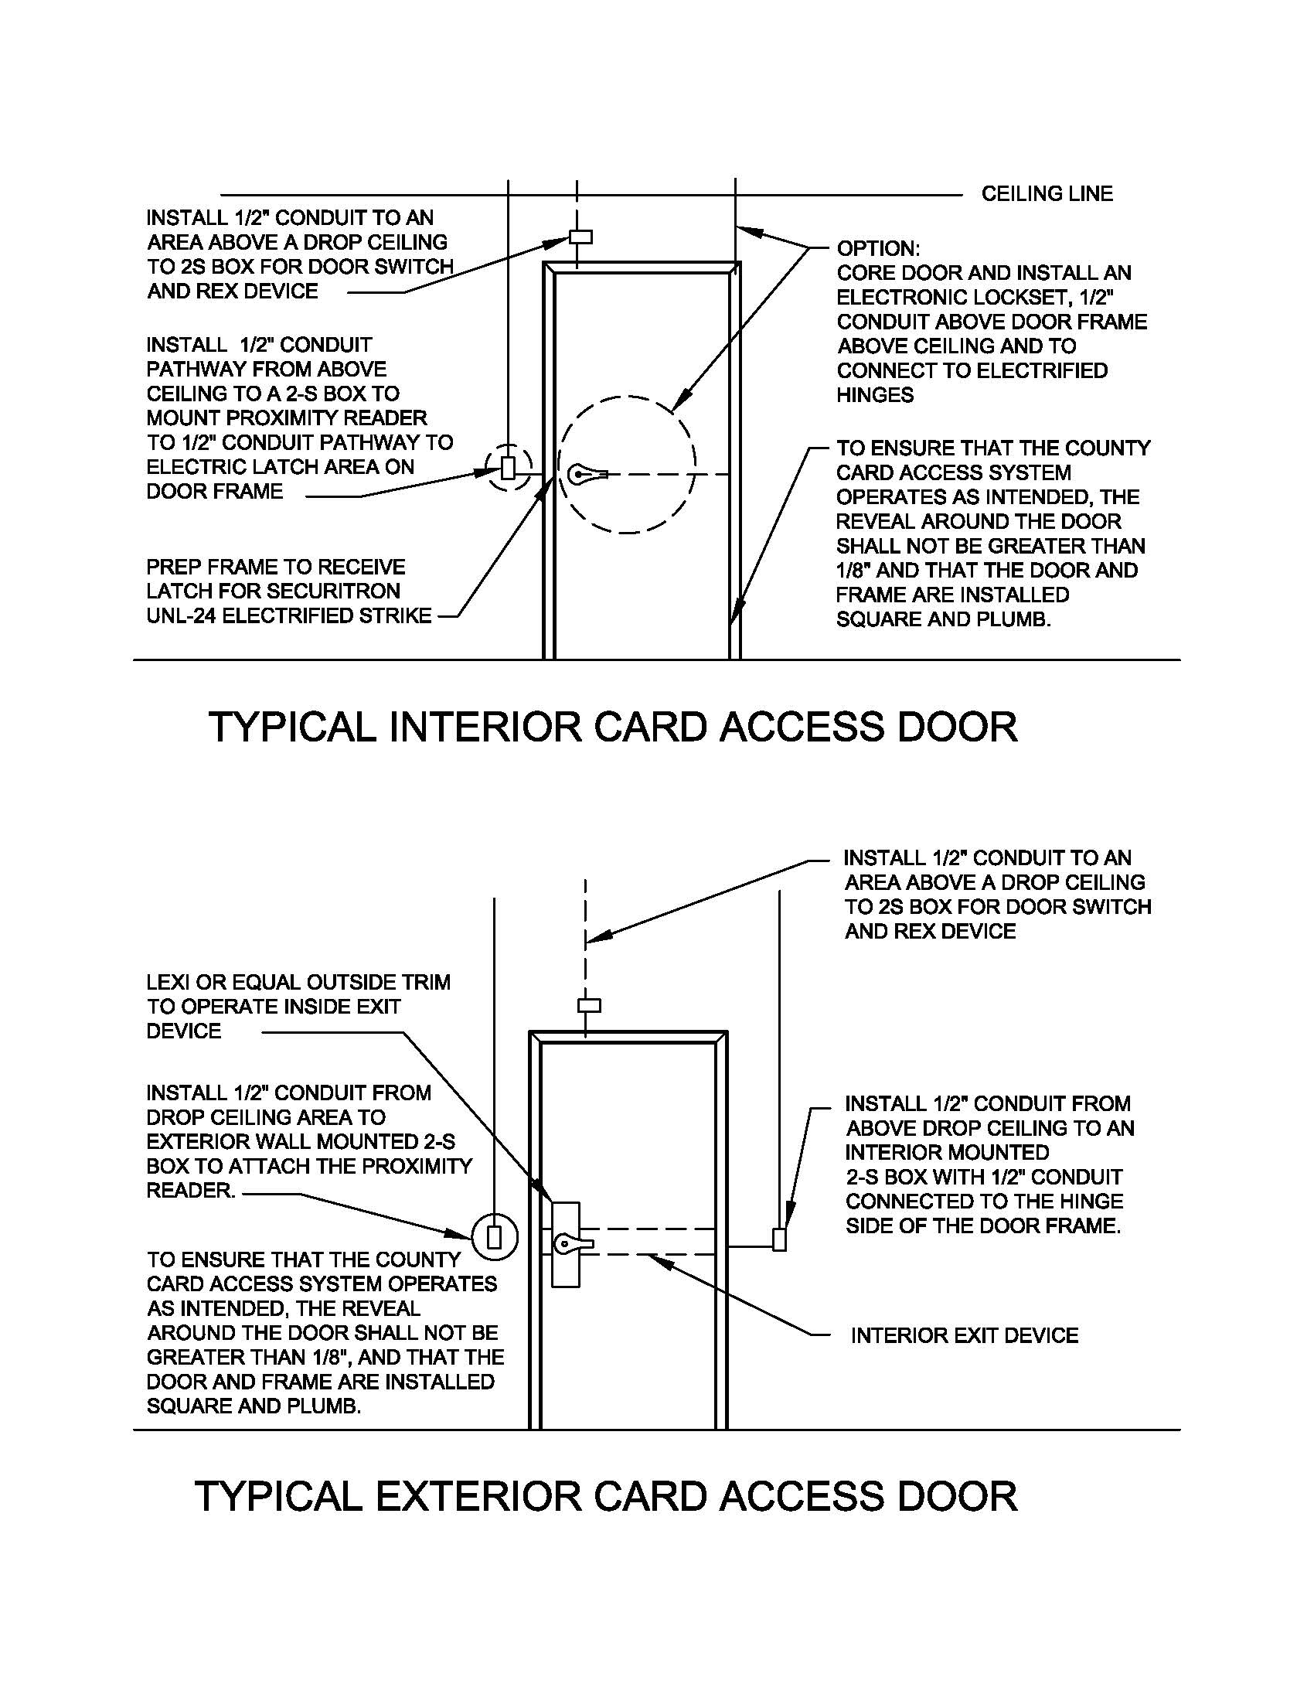
Figure 1 - Typical card access door installation guidelines.
Figure 2 - Von Duprin cut sheet
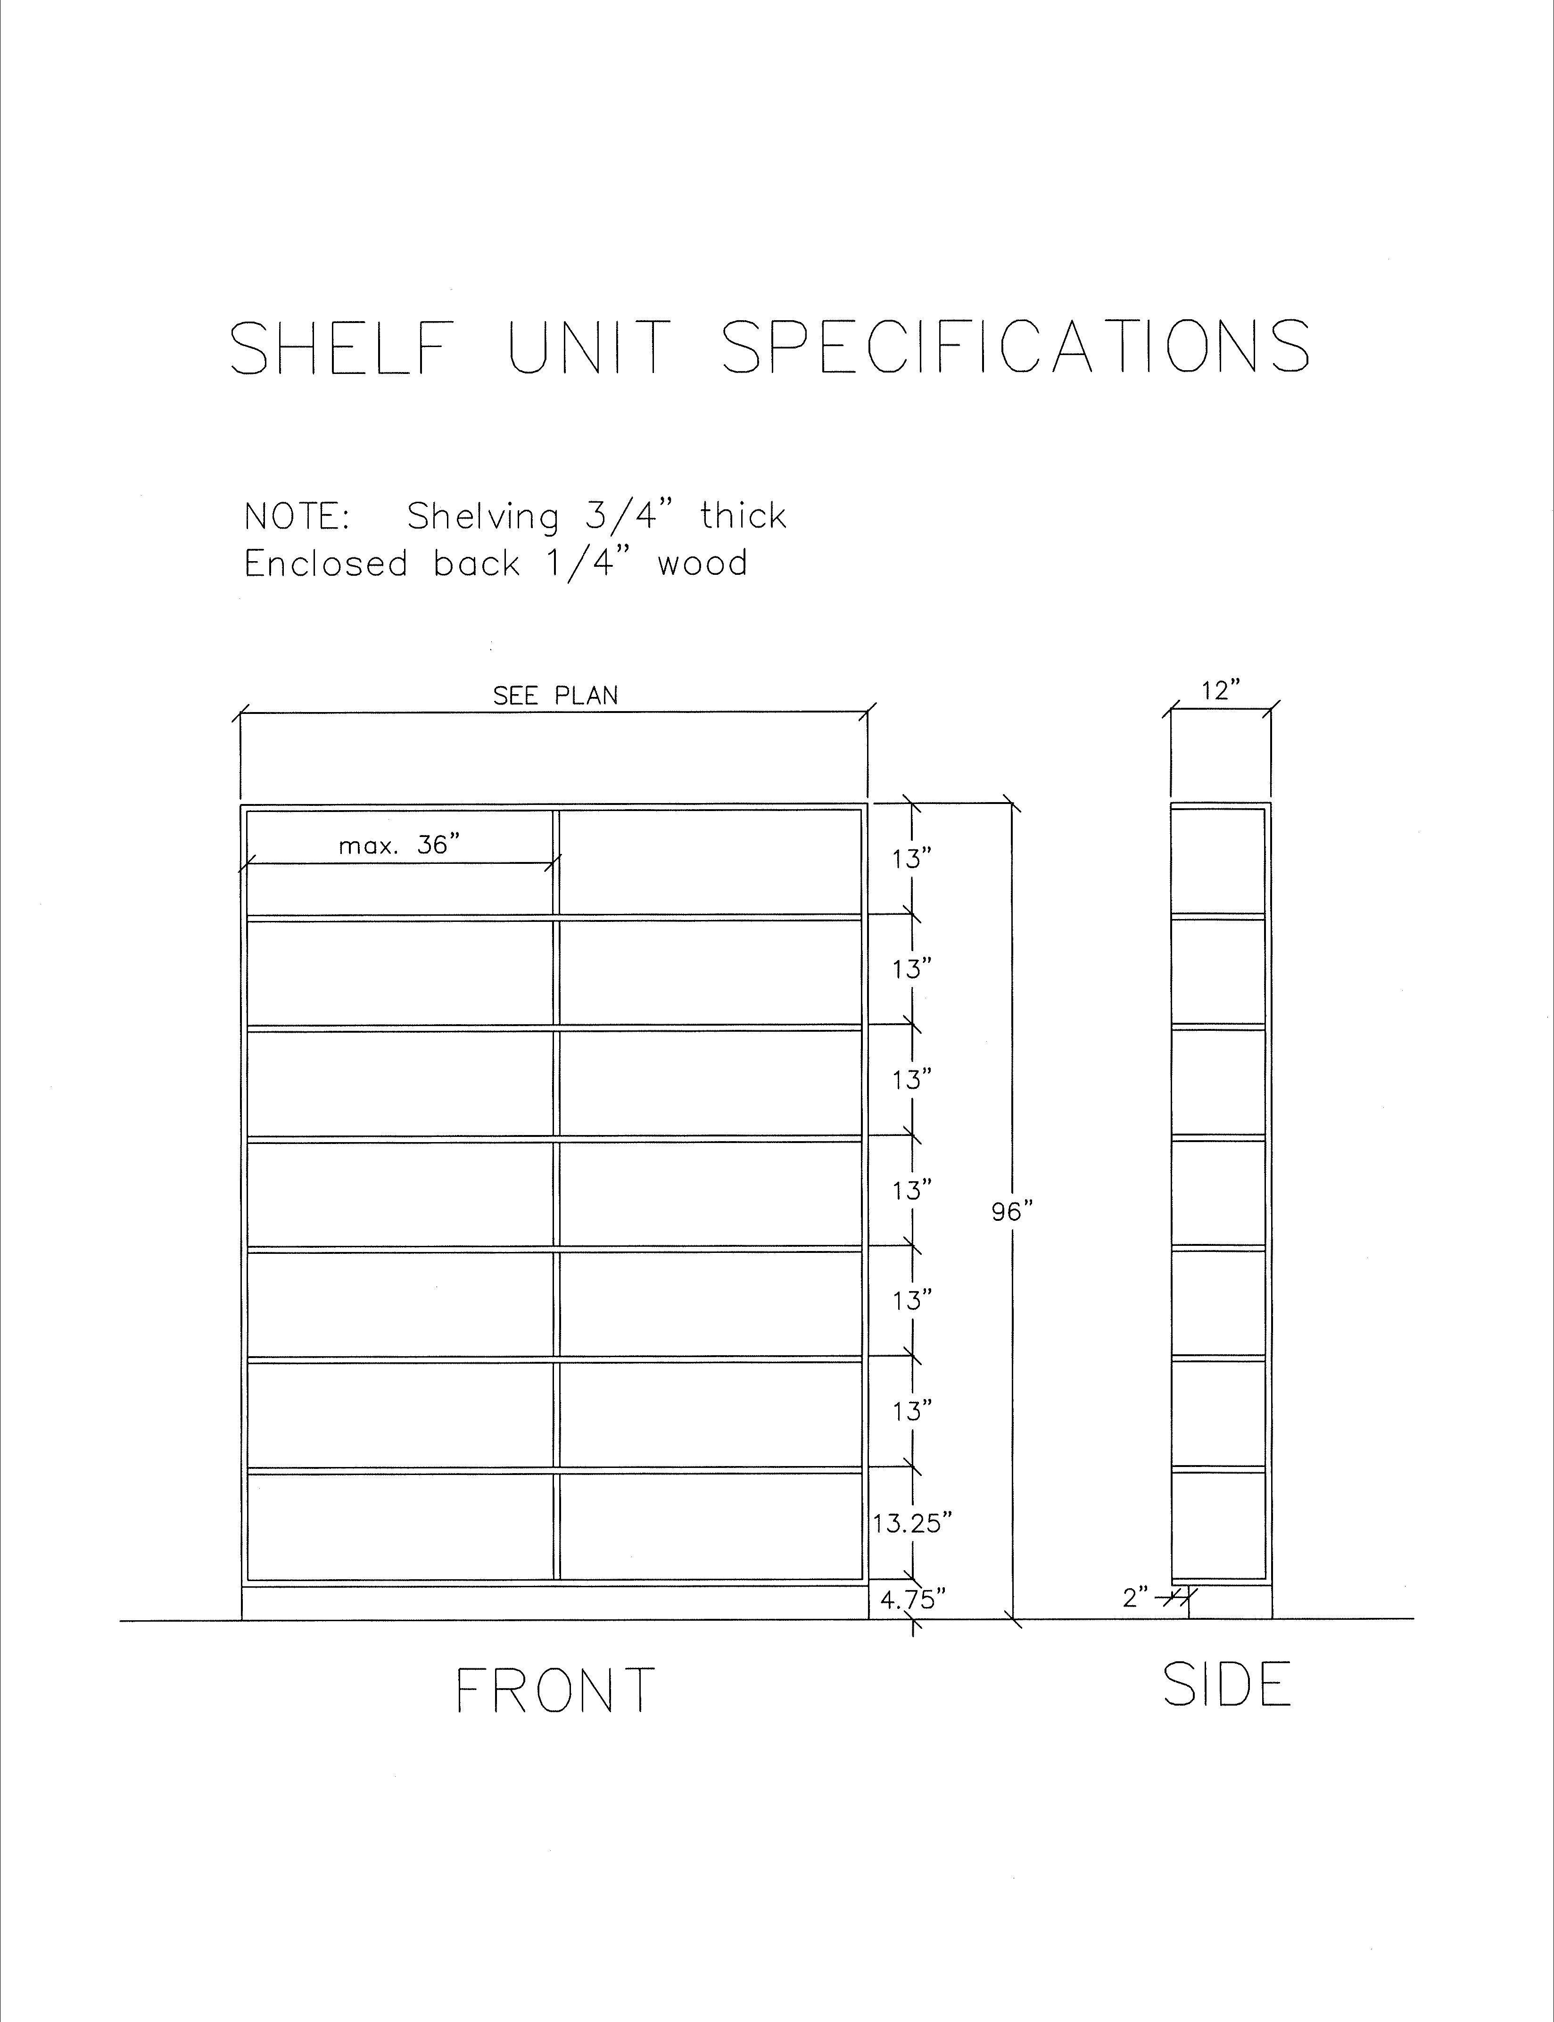
Figure 3 - Shelving Unit specifications

Figure 4 - Dietrich Backing

Figure 5 - Dietrich Backing cont'd
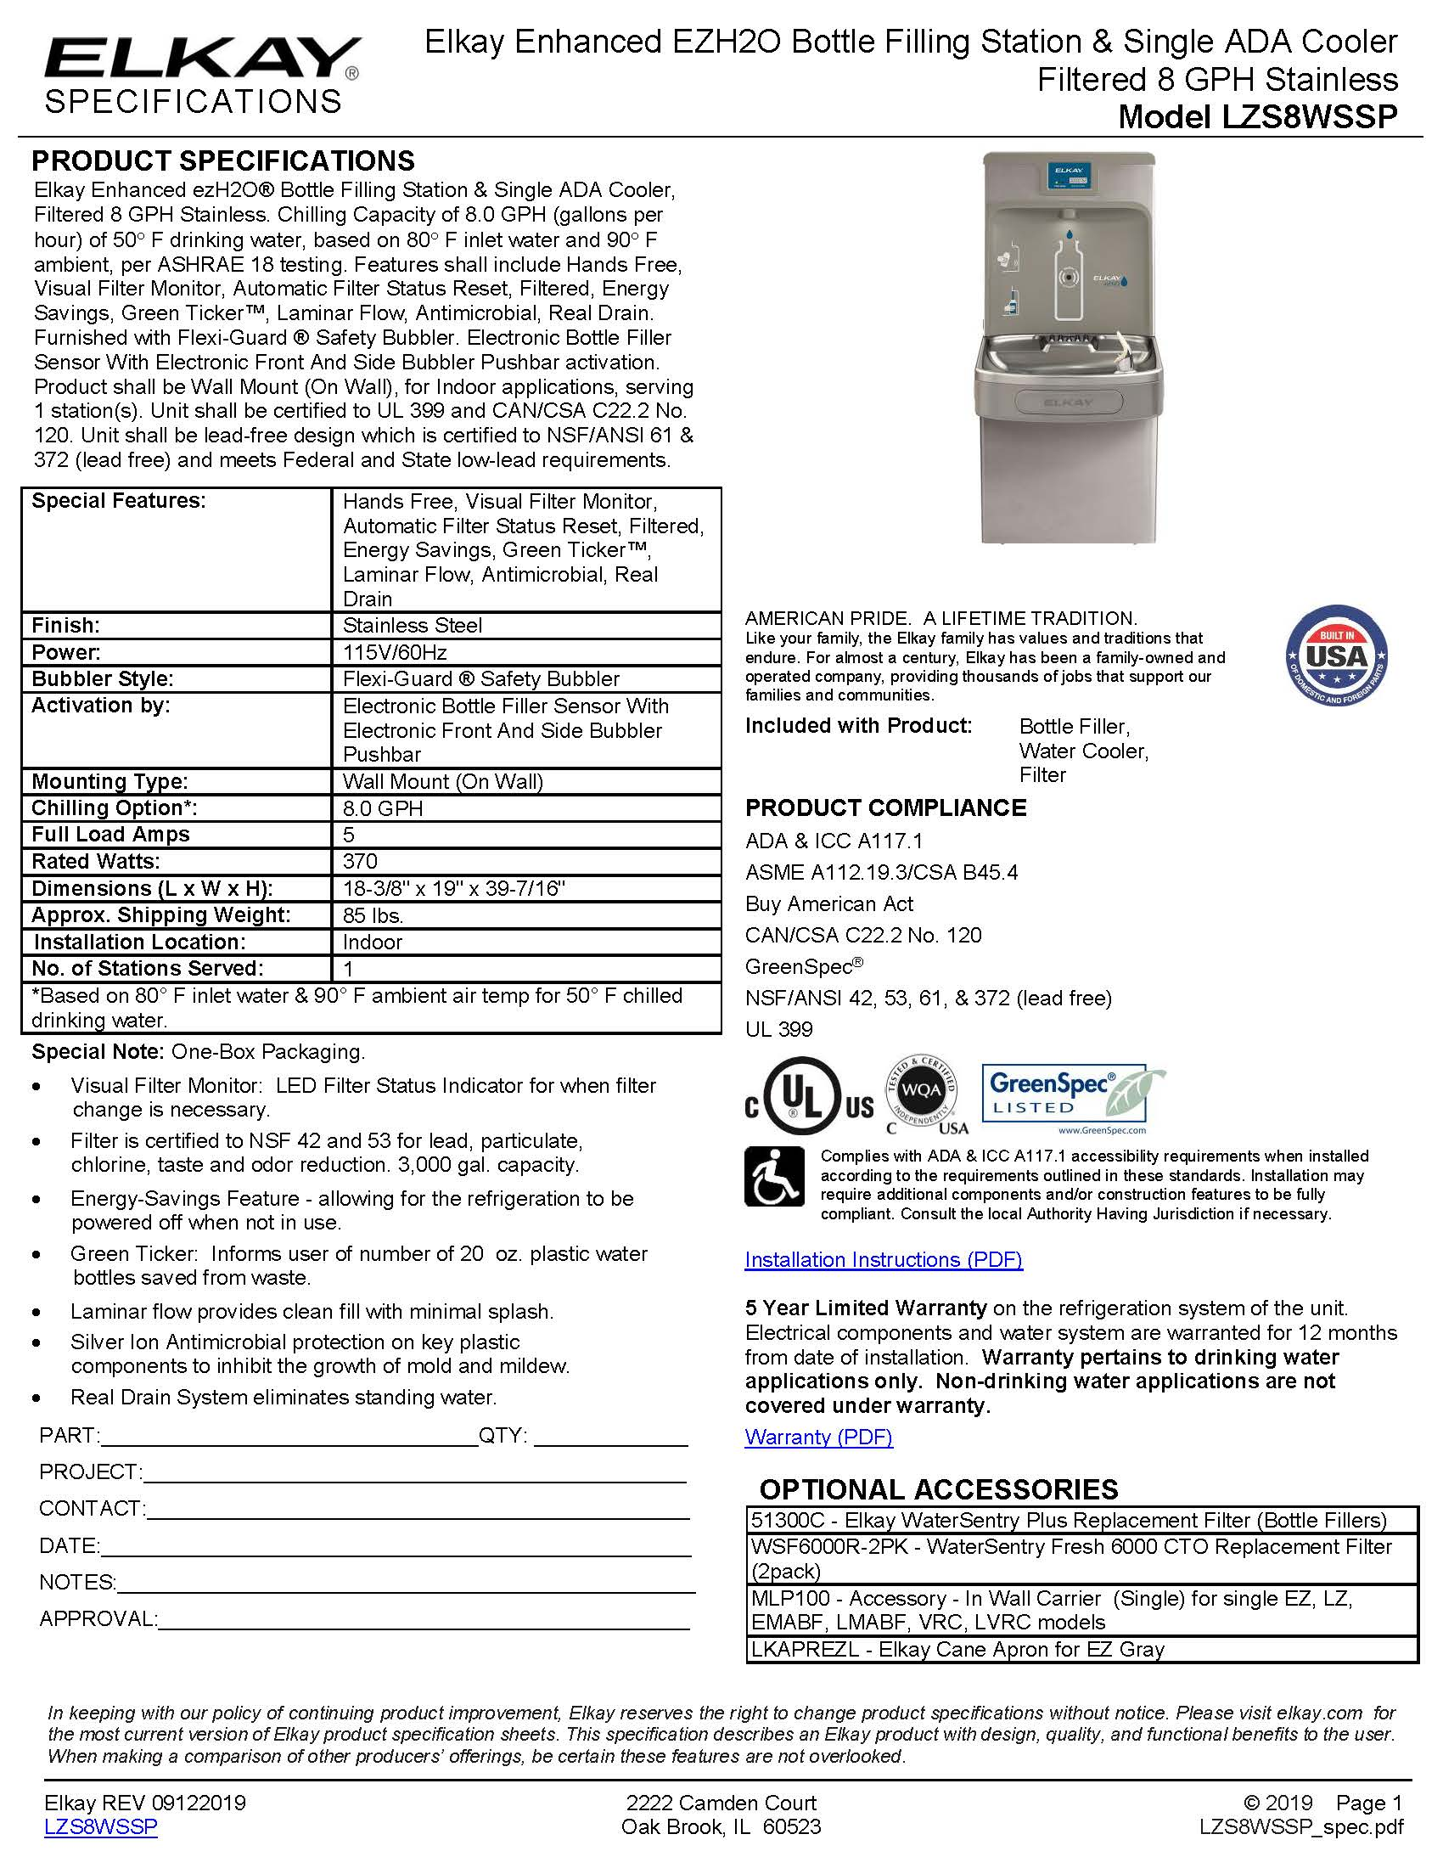
Figure 6 - Drinking Fountain specs
3.0 ROOM BY ROOM SPECIFICATIONS
Room Number | Floor | Walls | Comments
Disclaimer |  |  | - Approximate quantities are provided as a reference only with no guarantee of their accuracy. Landlord and Its representatives are solely responsible for field verifying all quantities and measurements.
100 (E) Lobby | Match exist’g | P1, match existing | - Add wall at cubicles 200 – 203 with (4) transaction windows. Refer to Figure 7 for Proposed Conceptual floor plan.  - Patch and paint existing walls as required.  - Patch flooring with salvaged tiles as required.  - Approximately 24 LF new drywall over stud wall with 4 transaction windows (6’-0” x 5’-0”) with (3) offset glass panels per window. Refer to County detail for transaction windows.  - Move existing guard station, electrical and data to location shown on plan.
100B Hallway |  |  | - Add full height wall to close off hall from Lobby.  - Add lockable door, with vision panel, storeroom function, keyed to existing grandmaster hierarchy. Card access system to be installed by County vendor with Landlord contractor providing conduit pathways per Figure 1. Match existing card access system. See Section 1.17.
101 (N) Reception | C1 | P1, match existing | - Enclose Reception 101 area with walls, doors and transaction windows. Refer to Figure 7 for Proposed Conceptual floor plan.  - Demolish approximately 24 LF of pony wall with built-in transaction counter.  - Demolish approximately 95 SF ceramic tile. Salvage tiles for patching.  - Replace, add and/or relocate suspended ceiling, components as required to match existing and provide a uniform grid and appearance throughout room. See Section 1.1 for additional information.  - Replace, add, and/or relocate lighting fixtures as required to provide even illumination and one fixture type throughout the room. See Section 1.2 for additional information.  - Replace, add and/or relocate HVAC components as required to provide a balanced air flow and even temperature throughout the room and adjacent spaces. See Section 1.3 for additional information.  - Provide air balance test and report for rebalanced rooms.  - Relocate and/or add light switches/power outlets as required to be convenient to the entrance to the room and other convenient locations. See Sections 1.2 and 1.21 for additional information. COUNTY to approve new locations at rough-in phase.  - Relocate TV/Data/electrical/backing to be outside of room in Lobby area. Refer to conceptual floor plan.  - Relocate kiosk/data/electrical to be outside of room in Lobby area. Refer to conceptual floor plan.  - Approximately 39 LF new drywall over stud wall with openings for 2 doors and 2 transaction windows (6’-0” x 5’-0”) with (3) offset glass panels per window. Refer to County detail for transaction windows.  - Replace approximately 95 SF ceramic tile floor with new carpet.  - Approximately 323 SF new carpet tiles.  - (1) duplex convenience receptacle power outlet in appropriate location for cleaning crew.  - Approximately (1) dedicated electrical circuit or as required per furniture plan for new modular furniture and equipment. See Section 1.21 for additional information and furniture vendor plan to be provided.  - Approximately (3) data/phone outlets, 1 for modular furniture, 2 for card access at new doors. COUNTY to approve locations at rough-in stage.  - (2) doors with hardware. Storeroom function, keyed to existing grandmaster hierarchy. Card access system to be installed by County vendor with Landlord contractor providing conduit pathways per Figure 1. Match existing card access system. See Section 1.17.
125 Classroom | C1 | P1, P2 | - Remove existing door, fill in opening.  - Move instructor desk as shown on plan. Add electrical and data as necessary.  - Add lockable door with vision panel, classroom function in location shown on plan. Key to existing grandmaster hierarchy.
126 Child Care | C1 | P1, P2 | - Add lockable door with vision panel, classroom function in location shown on plan. Key to existing grandmaster hierarchy.
128 Open Office | C1 | P1, P2 | - Add full height wall to close off open office from Lobby.  - Add lockable door with vision panel, storeroom function, keyed to existing grandmaster hierarchy. Card access system to be installed by County vendor with Landlord contractor providing conduit pathways per Figure 1. Match existing card access system. See Section 1.17.  - County vendor to add “furniture” door at cubicle 238 with card reader and move printers as shown on plan. Landlord to provide conduit pathways and reroute electrical as required.
Exterior Patio |  |  | - To address security issue of unwanted visitors entering patio: Add commercial metal pergola with architectural screens extending out from existing cover. COUNTY to approve design.
Deferred Maintenance items (no charge to County) All Rooms | C1 | P1, P2 | - Interior paint: refer to attached scope of work for paint colors and accent wall locations.  - Carpet Replacement: Existing carpet to be replaced with carpet tiles. Refer to attached scope of work for carpet selection and areas to be replaced.

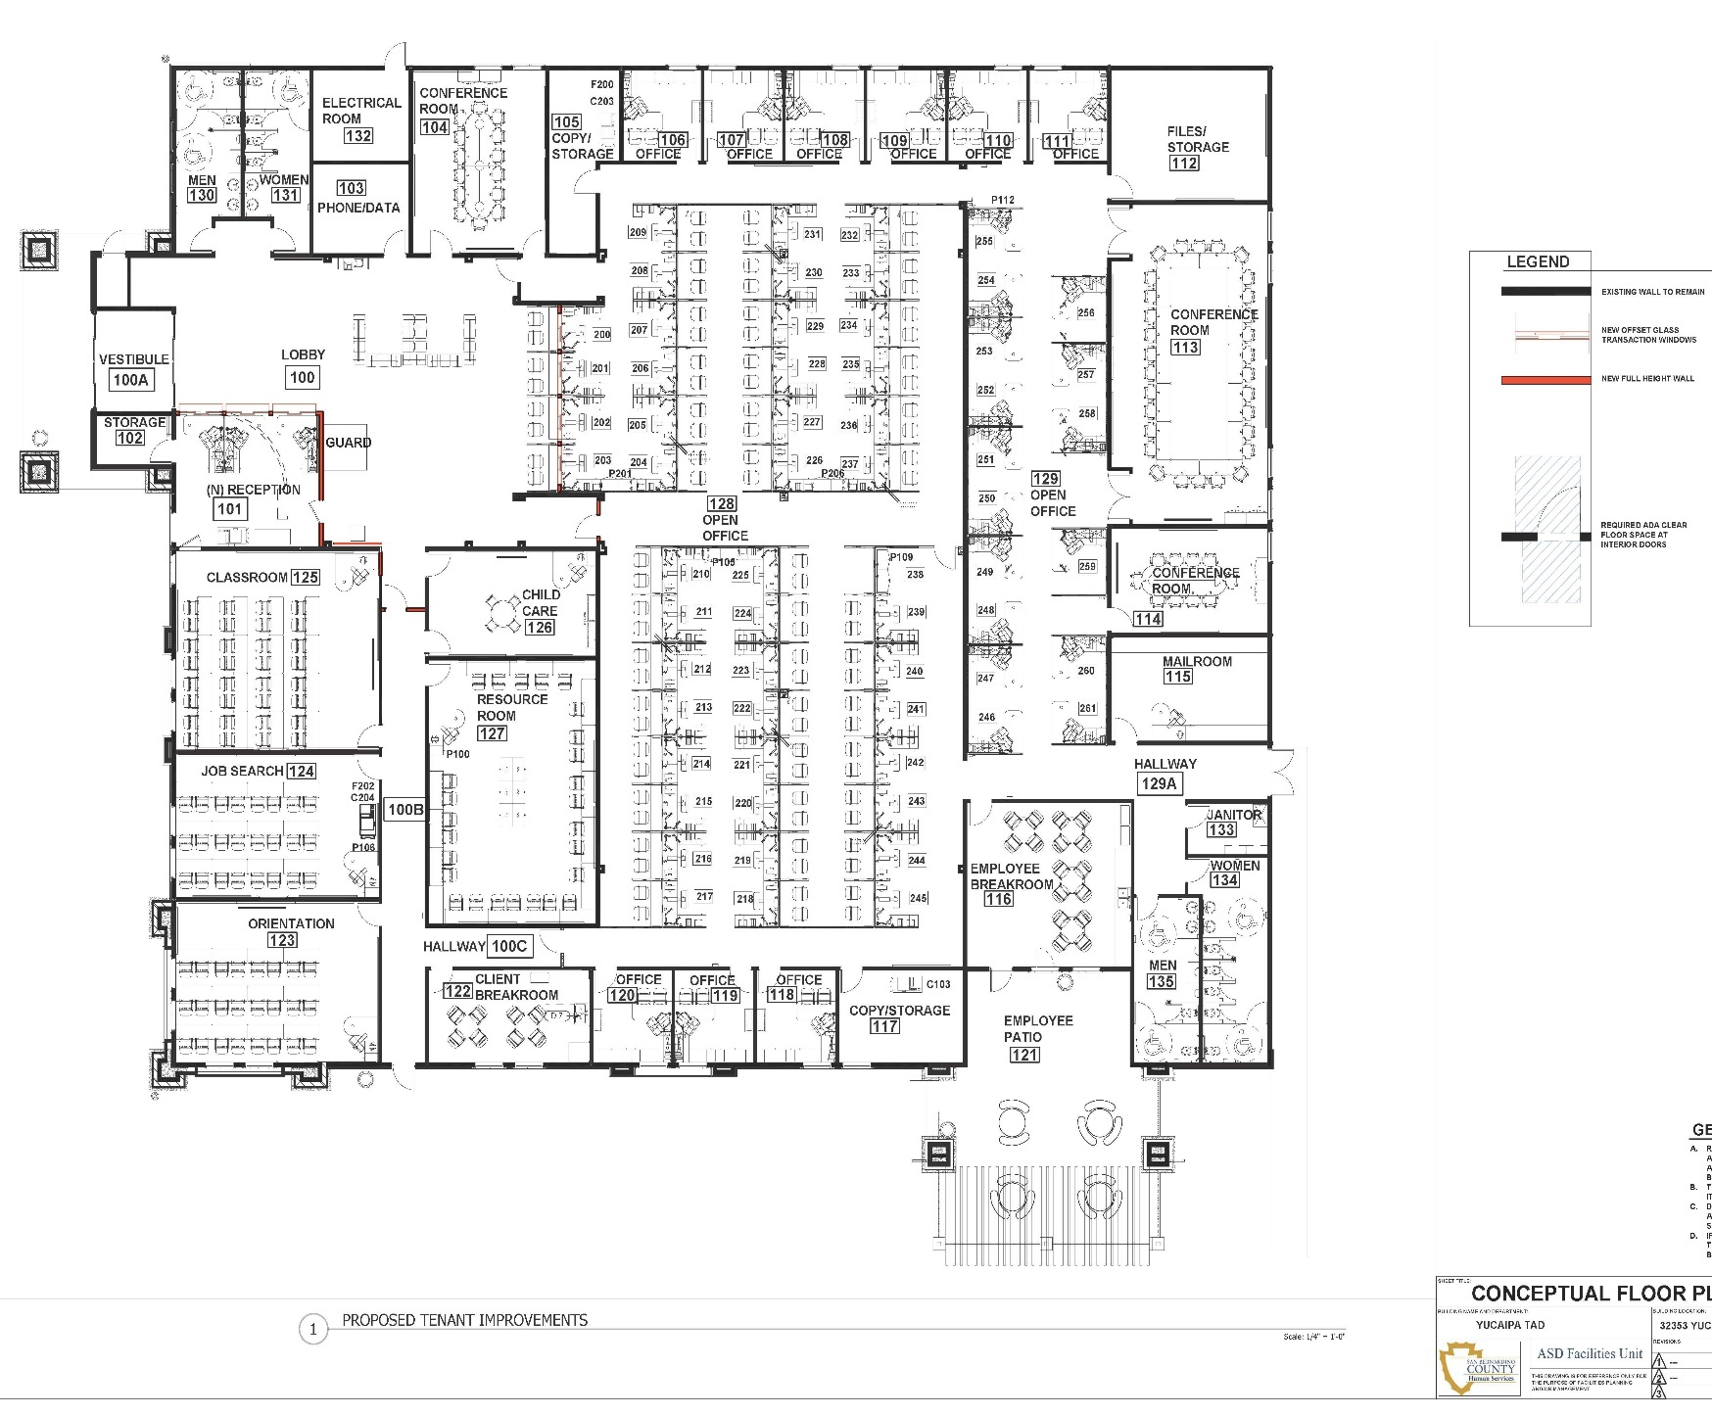

Figure 7 - Proposed Floor Plan
EXHIBIT “H”

Campaign Contribution Disclosure
(SB 1439)

DEFINITIONS

Actively supporting the matter: (a) Communicate directly with a member of the Board of Supervisors or other County elected officer [Sheriff, Assessor-Recorder-Clerk, District Attorney, Auditor-Controller/Treasurer/Tax Collector] for the purpose of influencing the decision on the matter; or (b) testifies or makes an oral statement before the County in a proceeding on the matter for the purpose of influencing the County’s decision on the matter; or (c) communicates with County employees, for the purpose of influencing the County’s decision on the matter; or (d) when the person/company’s agent lobbies in person, testifies in person or otherwise communicates with the Board or County employees for purposes of influencing the County’s decision in a matter.

Agent: A third-party individual or firm who, for compensation, is representing a party or a participant in the matter submitted to the Board of Supervisors. If an agent is an employee or member of a third-party law, architectural, engineering or consulting firm, or a similar entity, both the entity and the individual are considered agents.
Otherwise related entity: An otherwise related entity is any for-profit organization/company which does not have a parent-subsidiary relationship but meets one of the following criteria:
- One business entity has a controlling ownership interest in the other business entity;
- there is shared management and control between the entities; or
- a controlling owner (50% or greater interest as a shareholder or as a general partner) in one entity also is a controlling owner in the other entity.
For purposes of (2), “shared management and control” can be found when the same person or substantially the same persons own and manage the two entities; there are common or commingled funds or assets; the business entities share the use of the same offices or employees, or otherwise share activities, resources or personnel on a regular basis; or there is otherwise a regular and close working relationship between the entities.
Parent-Subsidiary Relationship: A parent-subsidiary relationship exists when one corporation has more than 50 percent of the voting power of another corporation.

Lessor must respond to the questions on the following page. If a question does not apply respond N/A or Not Applicable.

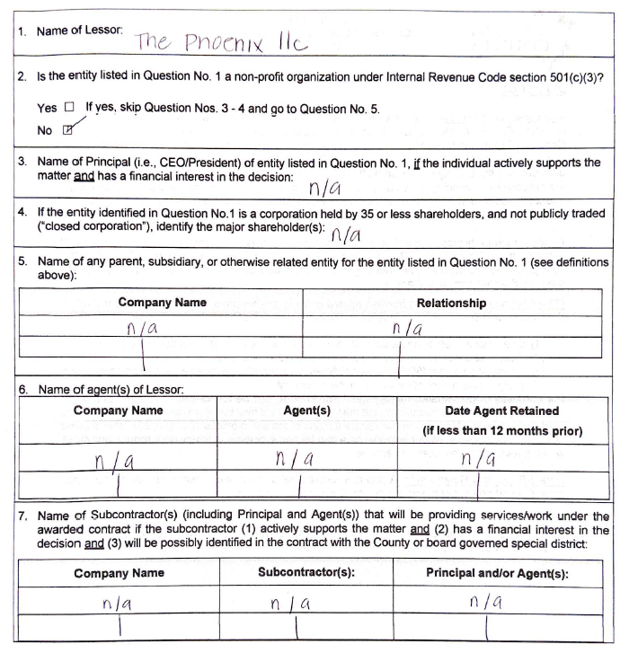

EXHIBIT "I"
PREVAILING WAGE REQUIREMENTS
- In the event all or a portion of the Scope of Work in the Contract requires the payment of prevailing wages as required by California state law, and compliance with the following requirements:
  - Determination of Prevailing Rates:
Pursuant to Labor Code sections 1770, et seq., the County has obtained from the Director of the Department of Industrial Relations (DIR) pursuant to the California Labor Code, the general prevailing rates of per diem wages and the prevailing rates for holiday and overtime work in the locality in which the Scope of Work is to be performed. Copies of said rates are on file with the County, will be made available for inspection during regular business hours, may be included elsewhere in the specifications for the Scope of Work, and are also available online at www.dir.ca.gov. The wage rate for any classification not listed, but which may be required to execute the Scope of Work, shall be commensurate and in accord with specified rates for similar or comparable classifications for those performing similar or comparable duties. In accordance with Labor Code section 1773.2, the Contractor shall post, at appropriate and conspicuous locations on the job site, a schedule showing all applicable prevailing wage rates and shall comply with the requirements of Labor Code sections 1773, et seq.
  - Payment of Prevailing Rates
Each worker of the Contractor, or any subcontractor, engaged in the Scope of Work, shall be paid not less than the general prevailing wage rate, regardless of any contractual relationship which may be alleged to exist between the Contractor or any subcontractor, and such worker.
  - Prevailing Rate Penalty
The Contractor shall, as a penalty, forfeit two hundred dollars ($200.00) to the County for each calendar day or portion thereof, for each worker paid less than the prevailing rates as determined by the Director of the DIR for such work or craft in which such worker is employed by the Contractor or by any subcontractor in connection with the Scope of Work. Pursuant to California Labor Code section 1775, the difference between such prevailing wage rates and the amount paid to each worker for each calendar day, or portion thereof, for which each worker was paid less than the prevailing wage rate, shall be paid to each worker by the Contractor.
  - Ineligible Contractors:
Pursuant to the provisions of Labor Code section 1777.1, the Labor Commissioner publishes and distributes a list of contractors ineligible to perform work as a contractor or subcontractor on a public works project. This list of debarred contractors is available from the DIR website at http://www.dir.ca.gov/Public-Works/PublicWorks.html. Any contract entered into between a contractor and a debarred subcontractor is void as a matter of law. A debarred subcontractor may not receive any public money for performing work as a subcontractor on a public works contract, and any public money that may have been paid to a debarred subcontractor by a contractor on the project shall be returned to the County. The Contractor shall be responsible for the payment of wages to workers as a debarred subcontractor who has been allowed to work on the Scope of Work.
  - Payroll Records:
    - Pursuant to California Labor Code section 1776, the Contractor and each subcontractor, shall keep accurate certified payroll records, showing the name, address, social security number, work classification, straight time and overtime hours worked each day and week, and the actual per diem wages paid to each journeyman, apprentice, worker or other employee employed by them in connection with the Scope of Work. The payroll records enumerated herein shall be verified by a written declaration made under penalty of perjury that the information contained in the payroll record is true and correct and that the Contractor or subcontractor has complied with the requirements of the California Labor Code sections 1771, 1811, and 1815 for any Scope of Work performed by his or her employees. The payroll records shall be available for inspection at all reasonable hours at the principal office of the Contractor on the following basis:
      - A certified copy of an employee's payroll record shall be made available for inspection or furnished to such employee or his/her authorized representative on request;
      - A certified copy of all payroll records shall be made available for inspection or furnished upon request to the County, the Division of Labor Standards Enforcement of the DIR;
      - A certified copy of payroll records shall be made available upon request to the public for inspection or copies thereof made; provided, however, that a request by the public shall be made through either the County or the Division of Labor Standards Enforcement. If the requested payroll records have not been previously provided to the County or the Division of Labor Standards Enforcement, the requesting party shall, prior to being provided the records, reimburse the cost of preparation by the Contractor, subcontractor and the entity through which the request was made; the public shall not be given access to such records at the principal office of the Contractor;
      - The Contractor shall file a certified copy of the payroll records with the entity that requested such records within ten (10) days after receipt of a written request; and
      - Copies provided to the public, by the County or the Division of Labor Standards Enforcement shall be marked or obliterated in such a manner as to prevent disclosure of an individual's name, address and social security number. The name and address of the Contractor or any subcontractor, performing a part of the Scope of Work shall not be marked or obliterated. The Contractor shall inform the County of the location of payroll records, including the street address, city and county and shall, within five (5) working days, provide a notice of a change of location and address.
    - The Contractor shall have ten (10) days from receipt of the written notice specifying in what respects the Contractor must comply with the above requirements. In the event Contractor does not comply with the requirements of this section within the ten (10) day period, the Contractor shall, as a penalty to the County, forfeit one-hundred dollars ($100.00) for each calendar day, or portion thereof, for each worker, until strict compliance is effectuated. Upon the request of the Division of Labor Standards Enforcement, such penalty shall be withheld from any portion of the payments then due or to become due to the Contractor.
  - Limits on Hours of Work:
Pursuant to California Labor Code section 1810, eight (8) hours of labor shall constitute a legal day's work. Pursuant to California Labor Code section 1811, the time of service of any worker employed at any time by the Contractor or by a subcontractor, upon the Scope of Work or upon any part of the Scope of Work, is limited and restricted to eight (8) hours during any one calendar day and forty (40) hours during any one calendar week, except as provided for under Labor Code section 1815. Notwithstanding the foregoing provisions, work performed by employees of Contractor or any subcontractor, in excess of eight (8) hours per day and forty (40) hours during any one week, shall be permitted upon compensation for all hours worked in excess of eight (8) hours per day at not less than one and one-half (1½) times the basic rate of pay.
  - Penalty for Excess Hours:
The Contractor shall pay to the County a penalty of twenty-five dollars ($25.00) for each worker employed on the Scope of Work by the Contractor or any subcontractor, for each calendar day during which such worker is required or permitted to work more than eight (8) hours in any calendar day and forty (40) hours in any one calendar week, in violation of the provisions of the California Labor Code, unless compensation to the worker so employed by the Contractor is not less than one and one-half (1½) times the basic rate of pay for all hours worked in excess of eight (8) hours per day.
  - Senate Bill 854 (Chapter 28, Statutes of 2014) and Senate Bill 96 (Chapter 28, Statutes of 2017) Requirements:
    - Contractor shall comply with Senate Bill 854 and Senate Bill 96. The requirements include, but are not limited to, the following:
      - No contractor or subcontractor may be listed on a bid proposal for a public works project unless registered with the DIR pursuant to Labor Code section 1725.5, with limited exceptions from this requirements for bid purposes only as allowed under Labor Code section 1771.1(a).
      - No contractor or subcontractor may be awarded a contract for public work or perform work on a public works project unless registered with the DIR pursuant to Labor Code section 1725.5.
      - This project is subject to compliance monitoring and enforcement by the DIR.
      - As required by the DIR, Contractor is required to post job site notices, as prescribed by regulation, regarding compliance monitoring and enforcement by the DIR.
      - Contractors and all subcontractors must submit certified payroll records online to the Labor Commissioner for all public works projects.
        - The certified payroll must be submitted at least monthly to the Labor Commissioner.
        - The County reserves the right to require Contractor and all subcontractors to submit certified payroll records more frequently than monthly to the Labor Commissioner.
        - The certified payroll records must be in a format prescribed by the Labor Commissioner.
      - Registration with the DIR and the submission of certified payroll records to the Labor Commissioner are not required if the public works project is $25,000 or less when the project is for construction, alteration, demolition, installation or repair work, or if the public works project is $15,000 or less when the project is for maintenance work.

    - Labor Code section 1725.5 states the following:
“A contractor shall be registered pursuant to this section to be qualified to bid on, be listed in a bid proposal, subject to the requirements of Section 4104 of the Public Contract Code, or engage in the performance of any public work contract that is subject to the requirements of this chapter. For the purposes of this section, “contractor” includes a subcontractor as defined by Section 1722.1.
(a) To qualify for registration under this section, a contractor shall do all of the following:
(1) (A) Register with the Department of Industrial Relations in the manner prescribed by the department and pay an initial nonrefundable application fee of four hundred dollars ($400) to qualify for registration under this section and an annual renewal fee on or before July 1 of each year thereafter. The annual renewal fee shall be in a uniform amount set by the Director of Industrial Relations, and the initial registration and renewal fees may be adjusted no more than annually by the director to support the costs specified in Section 1771.3.
(B) Beginning June 1, 2019, a contractor may register or renew according to this subdivision in annual increments up to three years from the date of registration. Contractors who wish to do so will be required to prepay the applicable nonrefundable application or renewal fees to qualify for the number of years for which they wish to preregister.
(2) Provide evidence, disclosures, or releases as are necessary to establish all of the following:
(A) Workers' compensation coverage that meets the requirements of Division 4 (commencing with Section 3200) and includes sufficient coverage for any worker whom the contractor employs to perform work that is subject to prevailing wage requirements other than a contractor who is separately registered under this section. Coverage may be evidenced by a current and valid certificate of workers' compensation insurance or certification of self-insurance required under Section 7125 of the Business and Professions Code.
(B) If applicable, the contractor is licensed in accordance with Chapter 9 (commencing with Section 7000) of the Business and Professions Code.
(C) The contractor does not have any delinquent liability to an employee or the state for any assessment of back wages or related damages, interest, fines, or penalties pursuant to any final judgment, order, or determination by a court or any federal, state, or local administrative agency, including a confirmed arbitration award. However, for purposes of this paragraph, the contractor shall not be disqualified for any judgment, order, or determination that is under appeal, provided that the contractor has secured the payment of any amount eventually found due through a bond or other appropriate means.
(D) The contractor is not currently debarred under Section 1777.1 or under any other federal or state law providing for the debarment of contractors from public works.
(E) The contractor has not bid on a public works contract, been listed in a bid proposal, or engaged in the performance of a contract for public works without being lawfully registered in accordance with this section, within the preceding 12 months or since the effective date of the requirements set forth in subdivision (e), whichever is earlier. If a contractor is found to be in violation of the requirements of this paragraph, the period of disqualification shall be waived if both of the following are true:
(i) The contractor has not previously been found to be in violation of the requirements of this paragraph within the preceding 12 months.
(ii) The contractor pays an additional nonrefundable penalty registration fee of two thousand dollars ($2,000).
(b) Fees received pursuant to this section shall be deposited in the State Public Works Enforcement Fund established by Section 1771.3 and shall be used only for the purposes specified in that section.
(c) A contractor who fails to pay the renewal fee required under paragraph (1) of subdivision (a) on or before the expiration of any prior period of registration shall be prohibited from bidding on or engaging in the performance of any contract for public work until once again registered pursuant to this section. If the failure to pay the renewal fee was inadvertent, the contractor may renew its registration retroactively by paying an additional nonrefundable penalty renewal fee equal to the amount of the renewal fee within 90 days of the due date of the renewal fee.
(d) If, after a body awarding a contract accepts the contractor's bid or awards the contract, the work covered by the bid or contract is determined to be a public work to which Section 1771 applies, either as the result of a determination by the director pursuant to Section 1773.5 or a court decision, the requirements of this section shall not apply, subject to the following requirements:
(1) The body that awarded the contract failed, in the bid specification or in the contract documents, to identify as a public work that portion of the work that the determination or decision subsequently classifies as a public work.
(2) Within 20 days following service of notice on the awarding body of a determination by the Director of Industrial Relations pursuant to Section 1773.5 or a decision by a court that the contract was for public work as defined in this chapter, the contractor and any subcontractors are registered under this section or are replaced by a contractor or subcontractors who are registered under this section.
(3) The requirements of this section shall apply prospectively only to any subsequent bid, bid proposal, contract, or work performed after the awarding body is served with notice of the determination or decision referred to in paragraph (2).
(e) The requirements of this section shall apply to any bid proposal submitted on or after March 1, 2015, to any contract for public work, as defined in this chapter, executed on or after April 1, 2015, and to any work performed under a contract for public work on or after January 1, 2018, regardless of when the contract for public work was executed.
(f) This section does not apply to work performed on a public works project of twenty-five thousand dollars ($25,000) or less when the project is for construction, alteration, demolition, installation, or repair work or to work performed on a public works project of fifteen thousand dollars ($15,000) or less when the project is for maintenance work.”

    - Labor Code section 1771.1 states the following:
“(a) A contractor or subcontractor shall not be qualified to bid on, be listed in a bid proposal, subject to the requirements of Section 4104 of the Public Contract Code, or engage in the performance of any contract for public work, as defined in this chapter, unless currently registered and qualified to perform public work pursuant to Section 1725.5. It is not a violation of this section for an unregistered contractor to submit a bid that is authorized by Section 7029.1 of the Business and Professions Code or by Section 10164 or 20103.5 of the Public Contract Code, provided the contractor is registered to perform public work pursuant to Section 1725.5 at the time the contract is awarded.
(b) Notice of the requirement described in subdivision (a) shall be included in all bid invitations and public works contracts, and a bid shall not be accepted nor any contract or subcontract entered into without proof of the contractor or subcontractor's current registration to perform public work pursuant to Section 1725.5.
(c) An inadvertent error in listing a subcontractor who is not registered pursuant to Section 1725.5 in a bid proposal shall not be grounds for filing a bid protest or grounds for considering the bid nonresponsive, provided that any of the following apply:
(1) The subcontractor is registered prior to the bid opening.
(2) Within 24 hours after the bid opening, the subcontractor is registered and has paid the penalty registration fee specified in subparagraph (E) of paragraph (2) of subdivision (a) of Section 1725.5.
(3) The subcontractor is replaced by another registered subcontractor pursuant to Section 4107 of the Public Contract Code.
(d) Failure by a subcontractor to be registered to perform public work as required by subdivision (a) shall be grounds under Section 4107 of the Public Contract Code for the contractor, with the consent of the awarding authority, to substitute a subcontractor who is registered to perform public work pursuant to Section 1725.5 in place of the unregistered subcontractor.
(e) The department shall maintain on its Internet Web site a list of contractors who are currently registered to perform public work pursuant to Section 1725.5.
(f) A contract entered into with any contractor or subcontractor in violation of subdivision (a) shall be subject to cancellation, provided that a contract for public work shall not be unlawful, void, or voidable solely due to the failure of the awarding body, contractor, or any subcontractor to comply with the requirements of Section 1725.5 or this section.
(g) If the Labor Commissioner or his or her designee determines that a contractor or subcontractor engaged in the performance of any public work contract without having been registered in accordance with this section, the contractor or subcontractor shall forfeit, as a civil penalty to the state, one hundred dollars ($100) for each day of work performed in violation of the registration requirement, not to exceed an aggregate penalty of eight thousand dollars ($8,000) in addition to any penalty registration fee assessed pursuant to clause (ii) of subparagraph (E) of paragraph (2) of subdivision (a) of Section 1725.5.
(h)(1) In addition to, or in lieu of, any other penalty or sanction authorized pursuant to this chapter, a higher tiered public works contractor or subcontractor who is found to have entered into a subcontract with an unregistered lower tier subcontractor to perform any public work in violation of the requirements of Section 1725.5 or this section shall be subject to forfeiture, as a civil penalty to the state, of one hundred dollars ($100) for each day the unregistered lower tier subcontractor performs work in violation of the registration requirement, not to exceed an aggregate penalty of ten thousand dollars ($10,000).
(2) The Labor Commissioner shall use the same standards specified in subparagraph (A) of paragraph (2) of subdivision (a) of Section 1775 when determining the severity of the violation and what penalty to assess, and may waive the penalty for a first time violation that was unintentional and did not hinder the Labor Commissioner’s ability to monitor and enforce compliance with the requirements of this chapter.
(3) A higher tiered public works contractor or subcontractor shall not be liable for penalties assessed pursuant to paragraph (1) if the lower tier subcontractor’s performance is in violation of the requirements of Section 1725.5 due to the revocation of a previously approved registration.
(4) A subcontractor shall not be liable for any penalties assessed against a higher tiered public works contractor or subcontractor pursuant to paragraph (1). A higher tiered public works contractor or subcontractor may not require a lower tiered subcontractor to indemnity or otherwise be liable for any penalties pursuant to paragraph (1).
(i) The Labor Commissioner or his or her designee shall issue a civil wage and penalty assessment, in accordance with the provisions of Section 1741, upon determination of penalties pursuant to subdivision (g) and subparagraph (B) of paragraph (1) of subdivision (h). Review of a civil wage and penalty assessment issued under this subdivision may be requested in accordance with the provisions of Section 1742. The regulations of the Director of Industrial Relations, which govern proceedings for review of civil wage and penalty assessments and the withholding of contract payments under Article 1 (commencing with Section 1720) and Article 2 (commencing with Section 1770), shall apply.
(j)(1) Where a contractor or subcontractor engages in the performance of any public work contract without having been registered in violation of the requirements of Section 1725.5 or this section, the Labor Commissioner shall issue and serve a stop order prohibiting the use of the unregistered contractor or the unregistered subcontractor on all public works until the unregistered contractor or unregistered subcontractor is registered. The stop order shall not apply to work by registered contractors or subcontractors on the public work.
(2) A stop order may be personally served upon the contractor or subcontractor by either of the following methods:
(A) Manual delivery of the order to the contractor or subcontractor personally.
(B) Leaving signed copies of the order with the person who is apparently in charge at the site of the public work and by thereafter mailing copies of the order by first class mail, postage prepaid to the contractor or subcontractor at one of the following:
(i) The address of the contractor or subcontractor on file with either the Secretary of State or the Contractors’ State License Board.
(ii) If the contractor or subcontractor has no address on file with the Secretary of State or the Contractors’ State License Board, the address of the site of the public work.
(3) The stop order shall be effective immediately upon service and shall be subject to appeal by the party contracting with the unregistered contractor or subcontractor, by the unregistered contractor or subcontractor, or both. The appeal, hearing, and any further review of the hearing decision shall be governed by the procedures, time limits, and other requirements specified in subdivision (a) of Section 238.1.
(4) Any employee of an unregistered contractor or subcontractor who is affected by a work stoppage ordered by the commissioner pursuant to this subdivision shall be paid at his or her regular hourly prevailing wage rate by that employer for any hours the employee would have worked but for the work stoppage, not to exceed 10 days.
(k) Failure of a contractor or subcontractor, owner, director, officer, or managing agent of the contractor or subcontractor to observe a stop order issued and served upon him or her pursuant to subdivision (j) is guilty of a misdemeanor punishable by imprisonment in county jail not exceeding 60 days or by a fine not exceeding ten thousand dollars ($10,000), or both.
(l) This section shall apply to any bid proposal submitted on or after March 1, 2015, and any contract for public work entered into on or after April 1, 2015. This section shall also apply to the performance of any public work, as defined in this chapter, on or after January 1, 2018, regardless of when the contract for public work was entered.
(m) Penalties received pursuant to this section shall be deposited in the State Public Works Enforcement Fund established by Section 1771.3 and shall be used only for the purposes specified in that section.
(n) This section shall not apply to work performed on a public works project of twenty-five thousand dollars ($25,000) or less when the project is for construction, alteration, demolition, installation, or repair work or to work performed on a public works project of fifteen thousand dollars ($15,000) or less when the project is for maintenance work.”

    - Labor Code section 1771.4 states the following:
“a) All of the following are applicable to all public works projects that are otherwise subject to the requirements of this chapter:
(1) The call for bids and contract documents shall specify that the project is subject to compliance monitoring and enforcement by the Department of Industrial Relations.
(2) The awarding body shall post or require the prime contractor to post job site notices, as prescribed by regulation.
(3) Each contractor and subcontractor shall furnish the records specified in Section 1776 directly to the Labor Commissioner, in the following manner:
(A) At least monthly or more frequently if specified in the contract with the awarding body.
(B) In a format prescribed by the Labor Commissioner.
(4) If the contractor or subcontractor is not registered pursuant to Section 1725.5 and is performing work on a project for which registration is not required because of subdivision (f) of Section 1725.5, the unregistered contractor or subcontractor is not required to furnish the records specified in Section 1776 directly to the Labor Commissioner but shall retain the records specified in Section 1776 for at least three years after completion of the work.
(5) The department shall undertake those activities it deems necessary to monitor and enforce compliance with prevailing wage requirements.
(b) The Labor Commissioner may exempt a public works project from compliance with all or part of the requirements of subdivision (a) if either of the following occurs:
(1) The awarding body has enforced an approved labor compliance program, as defined in Section 1771.5, on all public works projects under its authority, except those deemed exempt pursuant to subdivision (a) of Section 1771.5, continuously since December 31, 2011.
(2) The awarding body has entered into a collective bargaining agreement that binds all contractors performing work on the project and that includes a mechanism for resolving disputes about the payment of wages.
(c) The requirements of paragraph (1) of subdivision (a) shall only apply to contracts for public works projects awarded on or after January 1, 2015.
(d) The requirements of paragraph (3) of subdivision (a) shall apply to all contracts for public work, whether new or ongoing, on or after January 1, 2016.”

- STATE PUBLIC WORKS APPRENTICESHIP REQUIREMENTS
  - State Public Works Apprenticeship Requirements:
    - The Contractor is responsible for compliance with Labor Code section 1777.5 and the California Code of Regulations, title 8, sections 230 – 230.2 for all apprenticeable occupations (denoted with “#” symbol next to craft name in DIR Prevailing Wage Determination), whether employed by the Contractor, subcontractor, vendor or consultant. Included in these requirements is (1) the Contractor’s requirement to provide notification (i.e. DAS-140) to the appropriate apprenticeship committees; (2) pay training fund contributions for each apprenticeable hour employed on the Contract; and (3) utilize apprentices in a minimum ratio of not less than one apprentice hour for each five journeyman hours by completion of Contract work (unless an exception is granted in accordance with Labor Code section 1777.5) or request for the dispatch of apprentices.
    - Any apprentices employed to perform any of the Scope of Work shall be paid the standard wage to apprentices under the regulations of the craft or trade for which such apprentice is employed, and such individual shall be employed only for the work of the craft or trade to which such individual is registered. Only apprentices, as defined in California Labor Code section 3077, who are in training under apprenticeship standards and written apprenticeship agreements under California Labor Code sections 3070 et seq. are eligible to be employed for the Scope of Work. The employment and training of each apprentice shall be in accordance with the provisions of the apprenticeship standards and apprentice agreements under which such apprentice is training.
  - Compliance with California Labor Code section 1777.5 requires all public works contractors to:
    - Submit Contract Award Information (DAS-140):
      - Although there are a few exemptions (identified below), all Contractors, regardless of union affiliation, must submit contract award information when performing on a California public works project.
      - The DAS-140 is a notification “announcement” of the Contractor’s participation on a public works project—it is not a request for the dispatch of an apprentice.
      - Contractors shall submit the contract award information (you may use form DAS 140) within 10 days of the execution of the prime contract or subcontract, but in no event later than the first day in which the Contractor has workers employed on the public work.
      - Contractors who are already approved to train apprentices (i.e. check “Box 1” on the DAS-140) shall only be required to submit the form to their approved program.
      - Contractors who are NOT approved to train apprentices (i.e. those that check either “Box 2” or “Box 3” on the DAS-140) shall submit the DAS-140 TO EACH of the apprenticeship program sponsors in the area of your public works project. For a listing of apprenticeship programs see
http://www.dir.ca.gov/Databases/das/pwaddrstart.asp.
    - Employ Registered Apprentices
      - Labor Code section 1777.5 requires that a contractor performing work in an “apprenticeable” craft must employ one (1) hour of apprentice work for every five (5) hours performed by a journeyman. This ratio shall be met prior to the Contractor’s completion of work on the project. “Apprenticeable” crafts are denoted with a pound symbol “#” in front of the craft name on the prevailing wage determination.
      - All Contractors who do not fall within an exemption category (see below) must request for dispatch of an apprentice from an apprenticeship program (for each apprenticeable craft or trade) by giving the program actual notice of at least 72 hours (business days only) before the date on which apprentices are required.
      - Contractors may use the “DAS-142” form for making a request for the dispatch of an apprentice.
      - Contractors who are participating in an approved apprenticeship training program and who did not receive sufficient number of apprentices from their initial request must request dispatch of apprentices from ALL OTHER apprenticeship committees in the project area in order to fulfill this requirement.
      - Contractor should maintain and submit proof (when requested) of its DAS-142 submittal to the apprenticeship committees (e.g. fax transmittal confirmation). A Contractor has met its requirement to employ apprentices only after it has successfully made a dispatch request to all apprenticeship programs in the project area.
      - Only “registered” apprentices may be paid the prevailing apprentice rates and must, at all times work under the supervision of a Journeyman (Cal. Code Regs., tit 8, § 230.1).
    - Make Training Fund Contributions
      - Contractors performing in apprenticeable crafts on public works projects, must make training fund contributions in the amount established in the prevailing wage rate publication for journeymen and apprentices.
      - Contractors may use the “CAC-2” form for submittal of their training fund contributions.
      - Contractors who do not submit their training fund contributions to an approved apprenticeship training program must submit their contributions to the California Apprenticeship Council (CAC), PO Box 420603, San Francisco, CA 94142-0603.
      - Training fund contributions to the CAC are due and payable on the 15th day of the month for work performed during the preceding month.
      - The “training” contribution amount identified on the prevailing wage determination shall not be paid to the worker, unless the worker falls within one of the exemption categories listed below.
  - Exemptions to Apprenticeship Requirements:
    - The following are exempt from having to comply with California apprenticeship requirements. These types of contractors do not need to submit a DAS-140, DAS-142, make training fund contributions, or utilize apprentices:
      - When the Contractor holds a sole proprietor license (“Owner-Operator”) and no workers were employed by the Contractor. In other words, the contractor performed the entire work from start to finish and worked alone.
      - Contractors performing in non-apprenticeable crafts. “Apprenticeable” crafts are denoted with a pound symbol “#” in front of the craft name on the prevailing wage determination.
      - When the Contractor has a direct contract with the Public Agency that is under $30,000.
      - When the project is 100% federally-funded and the funding of the project does not contain any city, county, and/or state monies (unless the project is administered by a state agency in which case the apprenticeship requirements apply).
      - When the project is a private project not covered by the definition of public works as found in Labor Code section 1720.
  - Exemption from Apprenticeship Rations:
    - The Joint Apprenticeship Committee shall have the discretion to grant a certificate, which shall be subject to the approval of the Administrator of Apprenticeship, exempting the Contractor from the 1-to-5 ratio set forth in this Section when it finds that any one of the following conditions are met:
      - Unemployment for the previous three-month period in such area exceeds an average of fifteen percent (15%); or
      - The number of apprentices in training in such area exceeds a ratio of 1-to-5 in relation to journeymen; or
      - The Apprenticeable Craft or Trade is replacing at least one-thirtieth (1/30) of its journeymen annually through apprenticeship training, either on a statewide basis or on a local basis; or
      - If assignment of an apprentice to any work performed under the Contract Documents would create a condition which would jeopardize such apprentice's life or the life, safety or property of fellow employees or the public at large, or if the specific task to which the apprentice is to be assigned is of such a nature that training cannot be provided by a journeyman.
    - When such exemptions from the 1-to-5 ratio between apprentices and journeymen are granted to an organization which represents contractors in a specific trade on a local or statewide basis, the member contractors will not be required to submit individual applications for approval to local Joint Apprenticeship Committees, provided they are already covered by the local apprenticeship standards.
  - Contractor’s Compliance:
    - The responsibility of compliance with this Section for all Apprenticeable Trades or Crafts is solely and exclusively that of the Contractor. All decisions of the Joint Apprenticeship Committee(s) under this Section are subject to the provisions of California Labor Code section 3081 and penalties are pursuant to Labor Code section 1777.7 and the determination of the Labor Commissioner.

